# ABSTRACT

“Online Fire Reporting System” is web-based application which manages the fire reporting incidents and sends the team accordingly. The main purpose of OFRS is to systematically record, store and update the fire team information and fire incidents.

The information from OFRS is used report fire incidents online. With the help of this software person can report fire accidents online and get fire reliefs immediately.

The system was developed using basic technologies such as MySQL database and PHP. The system is free of errors and very efficient and less time consuming due to the care taken to develop it.

All the phases of software development cycle are employed, and it is worthwhile to state that the system is user friendly and strong. Provision is made for future development in the system.

# Table of Contents

Certificate I

Acknowledgment II

Abstract III

Table of Contents IV, V

List of Figures VI

List of Tables VII

Chapter 1 1

Introduction 1

* 1. Problem Statement 1
  2. Objectives 1
  3. Scope 1

Chapter 2 2

Literary Survey 2

* 1. Traditional File Systems 2
  2. Pros and Cons of the Traditional Approach 2
  3. Downfall of Traditional Management System 5
  4. Introduction to the Database Management System 5
  5. Indicative areas for the use of a DBMS 6
  6. Advantages of a DBMS 6
  7. Components of a DBMS 7

Chapter 3 8

System Requirements 8

* 1. Hardware Requirements 8
  2. Software Requirements 8

Chapter 4 9

System Design 9

* 1. ER Diagram 9
  2. Schema Diagram 10

Chapter 5 11

Implementation 11

* 1. HTML, CSS and JavaScript 11
  2. PHP 12
  3. SQL(Structured Query Language) 13
  4. Code Snippets 13

Chapter 6 27

Snapshots 27

* 1. The Home Page and About Us Page 27
  2. The User Login and New User Register Page 28
  3. The Forgot Password and Password Reset Page 29
  4. The User Dashboard and User Profile Page 30
  5. The USER – Insert and Manage Records Page 31
  6. The User – View Income Report Page 32
  7. The User – View Expense Report Page 33
  8. The User – View Loan Report Page 35
  9. The User – View Budget Report Page 36
  10. ADMIN – Manage User and Manage User Log Page 37
  11. The Admin Profile and Admin Password Change Page 38
  12. The Admin – Type wise Log view 39

6-0 Tables 41

Chapter 7 45

Conclusion 45

References 46

**Fig No. Description Page No.**

#### Fig 2.1 Components of a DBMS 7

**Fig 4.1 ER Diagram 9**

#### Fig 4.2 Schema Diagram for HSE management System 10

**Fig 6.1 The Home Page and About Us Page 27**

#### Fig 6.2 The User Login and New User Register Page 28

**Fig 6.3 The Forgot Password and Password Reset Page 29**

#### Fig 6.4 The User Dashboard and User Profile Page 30

**Fig 6.5 The USER – Insert and Manage Records Page 31**

#### Fig 6.6

**Fig 6.7**

#### Fig 6.8

**Fig 6.9**

#### Fig 6.10

**Fig 6.11**

#### Fig 6.12

#### The User – View Income Report Page 32

#### The User – View Expense Report Page 33

#### The User – View Loan Report Page 35

#### The User – View Budget Report Page 36

#### ADMIN – Manage User and Manage User Log Page 37

#### The Admin Profile and Admin Password Change Page 38

#### The Admin – Type wise Log view 39

**Table No. Description Page No.**

#### Table 6-1

**Table 6-2**

#### Table 6-3

**Table 6-4**

**Table 6-5**

#### Admin Table 41

#### User Table 41

#### Log Table 42

#### Loan Table 42

#### Income Table 43

#### Table 6-6 Budget Table 43

#### Table 6-7 Expense Table 44

## Chapter-1

# Introduction

# Online Fire Reporting System is a web-based application. This application is used to report fire incidents immediately.

#### Problem Statement

# The reason why we selected Online Fire Reporting System is that it provides online platform for fire department which allows the citizens to submit ongoing fire incidents. Thereby it will help the said department to manage the report and assign the teams.

# The aim of this project Online Fire Reporting System (OFRS) is to meet the following objectives:

#### Objectives:

# The fire safety objectives of this chapter are to:

# prevent the occurrence of fire and explosion.

# reduce the risk to life caused by fire.

# reduce the risk of damage caused by fire to the ship, its cargo and the environment.

# contain, control and suppress fire and explosion in the compartment of origin and

# provide adequate and readily accessible means of escape for passengers and crew.

#### Scope:

The Household savings and expenditure Management System is a system basically used to automate the process and management of all expenditure of an individual.

# In Online Fire Reporting System, we use PHP and MySQL database. This is the project which keeps records of Teachers. Online Fire Reporting System has two modules i.e., admin and users.

# The two main users involved in this system are

# User (i.e., Devotees)

# Admin

# Admin Module

# Admin will be the user of this project who can control the whole website.

# Dashboard: In this section, the admin can briefly view information about fire incidents.

# Teams: In this section, admin can manage Teams (Add/Update/Delete).

# Reports: In this section, the admin can view fire incidents in a particular period and search the fire reporting/incidents.

# Website Setting: In this section, the admin changes the setting of a website like logos contents, etc.

# Admin can also manage own profile.

# Admin can also recover their own password.

#### User Module

#### Home: It is welcome page for user.

#### Users can visit the website and report any fire incidents.

#### Users can also track the fire incident reporting Status.

## Chapter-2

* 1. **Traditional System**

# Literary Survey

Earlier people used to remember the transaction made by them or they used to store them in the form of hard copy in big and bulky register but this system is being imposed they can save those records here only without wasting time and money on this.

The traditional approach usually consisted of custom built data records and registers with information tailored of that particular household. There are scenarios where people would not even have their own records, and would just remember the transactions made, where lots of confusions would arise.

Initially, these systems were very simple to use as they hardly had any proper planned system to maintain. People have been doing this for years, but this allowed them to have lot extra expenses and very little savings, proving not to be accurate. However, it has become very difficult for individuals to manage and rely on their data because there was no reliable system for them in place to enforce data standards or management.

### Pros and Cons of the Traditional Approach

#### Pros

* Simple
  + Matched existing people mindset.
  + People were not as interested in funding complicated information systems.
* Initially low-cost
  + Earlier computing was not viewed as beneficial.
  + Saving data in a hard copy was chosen as it was cheap, in order to save on cost

#### Cons

* Lack of maintaining record
  + People hardly made a proper record of data regarding expenses and savings.
  + They were unwilling to monitor the income and expenses with a proper plan.
* Unmanaged redundancy
  + Multiple instances of the same data appearing throughout various files, hard copy, and records.
  + Information updated in one place was not replicated to the other locations.
  + Though a record was maintained somehow, data redundancy was a big drawback.
* Data inconsistency
  + Redundant data stored in various locations was usually never stored the same way.
  + The record maintained was not properly managed.
* Lack of accurate data
  + Same data stored in multiple locations of hard copy maintained.
  + Caused unnecessary doubling of efforts for analysing and managing data.
* Highly unwanted expenses
  + Since the income was rarely managed, by keeping a record of expenses and savings, it led to improper management of household expenses.
  + Doubling of expenses as well as very less savings.

#### Downfall of Traditional Management System

Conceived in a relatively under-developed era, the technique of managing the expenses of one’s own income was very hard to be found in those people. They fail to have a proper planning of maintaining their household expenses and savings. People hardly had an idea of having a record of their own to manage their income. There are few scenarios where people had proper record of their expenses and savings. However, such traditional practices fall short in serving the needs of todays expectations and essentials for the following reasons:

* Inadequate failover capabilities
* Latency issues
* Insufficient interests by the individuals
* Lack of proper planning at times
* Increasing expenditure and inadequate savings
* Inability to maintain a proper record

For all of these reasons, such traditional practices are unable to deliver results which are accurate and those which help the individuals to have proper savings and limited expenses. Dedicating all the time to maintain a more precise record and plan was a tiresome task for those people. Hence, due to these various reasons, the downfall of the traditional system was inevitable.

#### Introduction to the Database Management System

A Database management system (DBMS) refers to the technology for creating and managing databases. Basically, a DBMS is a software tool to organize (create, retrieve, update and manage) data in a database.

The main aim of a DBMS is to supply a way to store and retrieve database information that is both convenient and efficient. By data, we mean known facts that can be recorded and that have embedded meaning. Normally people use software such as DBASE IV or V, Microsoft ACCESS, or EXCEL to store data in the form of database. A datum is a unit of Data. Meaningful data combines to form information.

Hence, information is interpreted data- data provided with semantics.MS ACCESS is one of the most common examples of database management software.

Database systems are meant to handle large collection of information. Management of data involves both defining structures for storage of information and providing mechanisms that can do the manipulation of those stored information. Moreover, the database system must ensure the safety of the information stored, despite system crash or attempts at unauthorized access.

#### Indicative areas for the use of a DBMS

* + - Airlines: reservations, schedules etc.
    - Telecom : calls made, customer details, network usage etc.
    - Universities : registration, results, grades, etc.
    - Sales: products, purchases, customers etc.
    - Banking: all transactions etc.

#### Advantages of a DBMS

A Database Management System has many advantages over the traditional file system used in the earlier days, such as:

▪ Data independence: Application programs should be as free or independent as possible from details of data representation and storage. DBMS can supply an abstract view of the data for insulating application code from such facts.

▪ Efficient data access: DBMS utilize a mixture of sophisticated concepts and techniques for storing and retrieving data competently and this feature becomes important in cases where the data is stored on external storage devices.

▪ Data integrity and Security : If data is accessed through the DBMS , the DBMS can enforce integrity constraint on the data

▪ Data administration: When several users share the data, integrating the administration

of data can offer major improvements. Experienced professionals understand the nature of the data being managed and can be responsible for organizing the data representation to reduce redundancy and make the data to retrieve efficiently.

#### Components of a DBMS

**DATABASE**

**APP**

**API**

**USER**

|  |  |  |  |
| --- | --- | --- | --- |
|  |  | **DBMS** | **API** |
|  |  |  |

### Fig 2.1 Components of a DBMS

**API**

**APP**

* **Users**: Users may be of any kind, such as data base administrators, system developers or database users.
* **Database application**: Database application may be Departmental, Personal, Organizational and /or Internal
* **DBMS**: Software that allows users to create and manipulate database access.
* **Database**: Collection of logical data as a single unit.

## Chapter 3

**Hardware Software Specification**

### Hardware Requirement

* + - Processor – Pentium IV or above
    - Ram – 2 GB or more

### Software Requirement

Technologies Used:

#### Server Side:

* + - XAMPP
    - MySql
    - FTP accessibility to upload the content to the server or modify them.
    - Server running on windows.

#### Client Side:

* + - Browser supporting HTML 5,PHP and CSS 3
    - Machine running windows.
    - Internet connection

# Chapter 4

# System Design

### ER Diagram

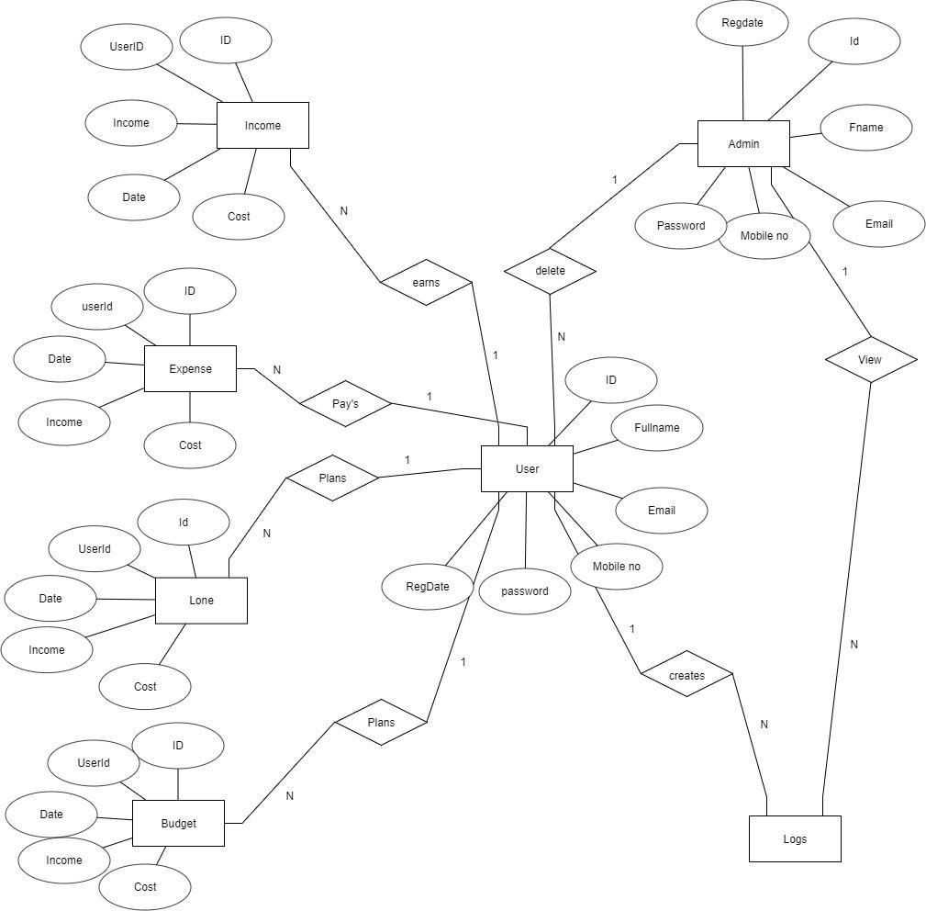

#### Fig 4.1 ER Diagram

* 1. **Schema Diagram**

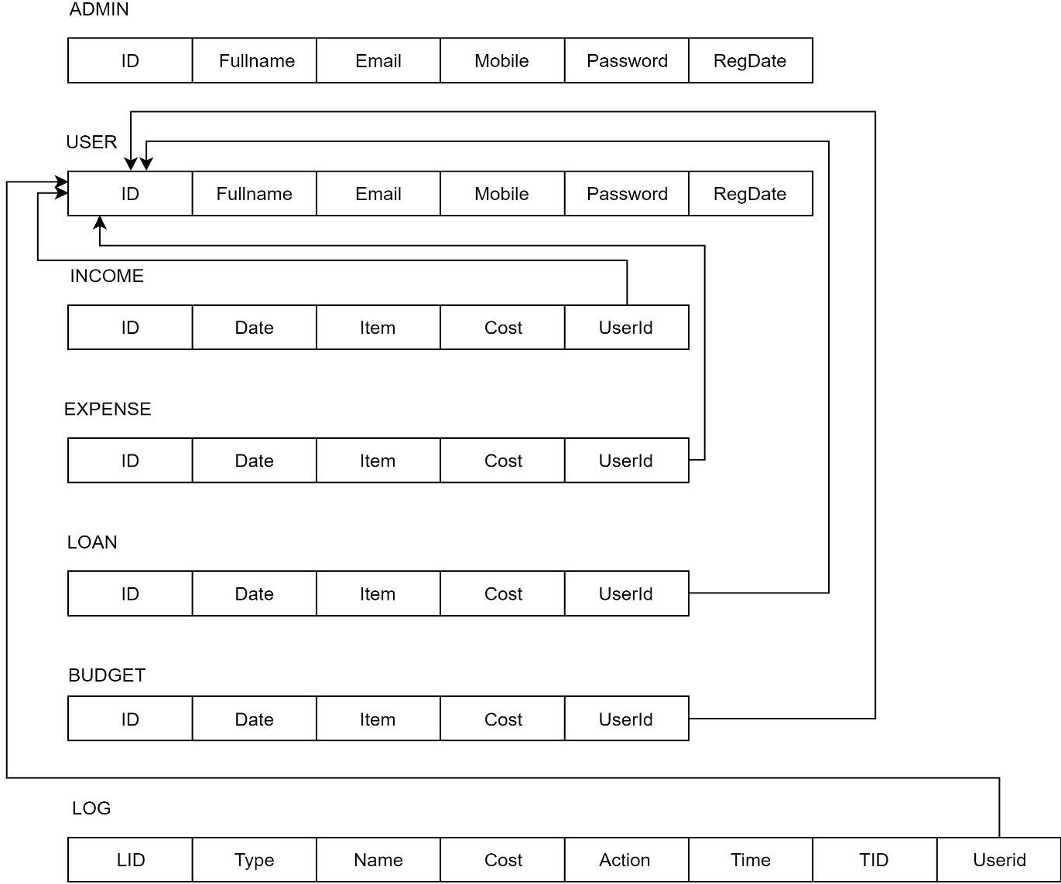

#### Fig 4.2 Schema Diagram

The above figure shows **Schema diagram** which describes inter-related things of interest in a specific domain of knowledge.

## Chapter 5

# Implementation

### HTML, CSS and JavaScript

HTML stands for Hypertext Markup Language, it is the standard markup language for creating web pages and web applications. With Cascading Style Sheets(CSS) and JavaScript it forms a triad of cornerstone technologies for the World Wide Web.

Web browsers receives HTML documents from a Web server or from local storage and render them into multimedia web pages. HTML describes the structure of a web page semantically and originally included cues for the appearance of the document.

HTML elements are the building blocks of HTML pages, with HTML constructs, images and other objects, such as interactive forms, may be embedded into the rendered page. It provides a means to create standard documents by denoting structural semantics for text such as headings, paragraphs, lists, links, quotes and other items. HTML elements are delineated by tags, return using angle brackets. Browsers do not display the HTML tags, but use them to interpret the content of the page.

#### Cascading Style Sheets(CSS)

It is a style sheet language used for describing the presentation of a document written in a markup language. Although most often used to set the visual style of web pages and user interface written in HTML, the language can be applied to any document, including plain **XML, SVG** and **XUL**, and is applicable to rendering in speech, or on other media. Along with HTML and JavaScript, CSS is a cornerstone technology used by most websites to create visually engaging web pages, user interfaces for web applications, and user interfaces for many mobile applications.

#### JavaScript

It is often abbreviated as JS, is a high level, dynamic, weakly typed, prototype based, multi- paradigm, and interpreted programming language. Alongside **HTML** and **CSS**, **JavaScript** is one of the three core technologies of World Wide Web content production. It is used to make webpages interactive and provide online programs, including video games.

#### PHP

**PHP** is a servlet-side scripting language designed primarily for web development but also used as a general-purpose programming language. Originally created by Rasmus Lerdorf in I994, the PHP reference implementation is now produced by The PHP Development Team. PHP originally stood for Personal Home Page, but it now stands for the recursive acronym PHP: Hypertext Preprocessor.

PHP code may be embedded into HTML or HTML5 markup, or it can be used in combination with various web template systems, web content management

systems and web frameworks. PHP code is usually processed by a PHP interpreter implemented as a module in the web server or as a Common Gateway interface (CGI) executable. The web server software combines the results of the interpreted and executed PHP code, which may beany type of data, including images, with the generated web page. PHP code may also be executed with a command-line interface (CLI) and can be used to implement standalone graphical applications.

The standard PHP interpreter, powered by the Zend Engine, is free software released under the PHP License. PHP has been widely ported and can be deployed on most web servers on almost every operating system and platform, free of charge.

The PHP language evolved without a written formal specification or standard until 2014, leaving the canonical PHP interpreter as a de facto standard. Since 2014 work has gone on to create a formal PHP specification.

**PHP** is a scripting language that helps people make web pages more interactive by allowing them to do more things.

A website programmed with PHP can have pages that are password protected. A website with no programming cannot do this without other complex things. Standard PHP file extensionsare:php,php3or, phtml, but a web server can be set up to use any extension.

#### SQL(Structured Query Language)

**SQL (Structured Query Language)** is a domain-specific language used in programming and designed for managing data held in a relational database Management system(RDBMS), or for stream processing in a relational data stream management system (RDSMS). In comparison to older read/write APIs like [SAM or VSAM, SQL offers two main advantages : first, it introduced the concept of accessing many records with one single command; and second, it eliminates the need to specify how to reach a record, e.g. with or without an index.

Originally based upon relational algebra and tuple relational calculus, SQL consists of a data definition language, data manipulation language, and data control language. The scope of SQL includes data insert, query, update and delete, schema creation and modification, and data access control. Although SQL is often described as, and to a great extent is, a declarative language (4GL), it also includes procedural elements.

SQL was one of the first commercial languages for Edgar F Codd's relational model, as described in his influential 1970 paper, "A Relational Model of Data for Large SharedDataBanks".91Despitenot entirely adhering to the relational model as described by Codd, it became the most widely used database language.

SQL became a standard of the American National Standards Institute(ANSI) in 1986 and of the International Organization for Standardization(ISO) in 1987. Since then, the standard has been revised to include a larger set of features. Despite the existence .of such standards, most SQL code is not completely portable among different data base systems without adjustments.

#### Code Snippets

* + 1. **Config – To establish connection**

This is a code snippet to show how PHP is used to connect to the local MySQL database using the localhost server.

<?php

$con=mysqli_connect("localhost", "root", "", "detsdb");

if(mysqli_connect_errno())

{

echo "Connection Fail".mysqli_connect_error();

}

?>

#### Admin- Login

<?php session_start(); error_reporting(0);

include('includes/dbconnection.php');

if(isset($_POST['login']))

{

$email=$_POST['email'];

$password=md5($_POST['password']);

$query=mysqli_query($con,"select ID from tbladmin where Email='$email' && Password='$password' ");

$ret=mysqli_fetch_array($query); if($ret>0){

$_SESSION['detsaid']=$ret['ID']; header('location:adminmanager.php');

}

else{

$msg="Invalid Details.";

}

}

?>

#### ADMIN – Logout

<?php session_start(); session_unset(); session_destroy();

header('location:admin.php');

?>

#### ADMIN – Manager

<?php session_start(); error_reporting(0);

include('includes/dbconnection.php');

if (strlen($_SESSION['detsaid']==0)) { header('location:logout.php');

} else{

//code deletion if(isset($_GET['delid']))

{

$rowid=intval($_GET['delid']);

$query=mysqli_query($con,"delete from tbluser where ID='$rowid'"); if($query){

echo "<script>alert('User has been successfully deleted');</script>"; echo "<script>window.location.href='adminmanager.php'</script>";

} else {

echo "<script>alert('Something went wrong. Please try again');</script>";

}

}

?>

#### ADMIN – Password Reset

<?php session_start();

include('includes/dbconnection.php'); error_reporting(0);

if (strlen($_SESSION['detsaid']==0)) { header('location:logout.php');

} else{ if(isset($_POST['submit']))

{

$userid=$_SESSION['detsaid'];

$cpassword=md5($_POST['currentpassword']);

$newpassword=md5($_POST['newpassword']);

$query=mysqli_query($con,"select ID from tbladmin where ID='$userid' and Password='$cpassword'");

$row=mysqli_fetch_array($query); if($row>0){

$ret=mysqli_query($con,"update tbladmin set Password='$newpassword' where ID='$userid'");

$msg= "Your password successully changed";

} else {

$msg="Your current password is wrong";

}

}

?>

#### ADMIN - Profile

<?php session_start(); error_reporting(0);

include('includes/dbconnection.php'); if (strlen($_SESSION['detsaid']==0)) { header('location:logout.php');

} else{ if(isset($_POST['submit']))

{

$userid=$_SESSION['detsaid'];

$fullname=$_POST['fullname'];

$mobno=$_POST['contactnumber'];

$query=mysqli_query($con, "update tbladmin set FullName ='$fullname', MobileNumber='$mobno' where ID='$userid'");

if ($query) {

$msg="Admin profile has been updated.";

}

else

{

$msg="Something Went Wrong. Please try again.";

}

}

?>

#### ADMIN - Insert

include('includes/dbconnection.php'); if(isset($_POST['submit']))

{

$fname=$_POST['name'];

$mobno=$_POST['mobilenumber'];

$email=$_POST['email'];

$password=md5($_POST['password']);

$ret=mysqli_query($con, "select Email from tbladmin where Email='$email' ");

$result=mysqli_fetch_array($ret); if($result>0){

$msg="This email associated with another account";

}

else{

$query=mysqli_query($con, "insert into tbladmin(FullName, MobileNumber, Email, Password) value('$fname', '$mobno', '$email', '$password' )");

if ($query) {

$msg="You have successfully registered";

}

else

{

$msg="Something Went Wrong. Please try again";

}

}

}

?>

#### USER – Login

<?php session_start(); error_reporting(0);

include('includes/dbconnection.php');

if(isset($_POST['login']))

{

$email=$_POST['email'];

$password=md5($_POST['password']);

$query=mysqli_query($con,"select ID from tbluser where Email='$email' && Password='$password' ");

$ret=mysqli_fetch_array($query); if($ret>0){

$_SESSION['detsuid']=$ret['ID']; header('location:dashboard.php');

}

else{

$msg="Invalid Details.";

}

}

?>

#### USER – Register

<?php session_start(); error_reporting(0);

include('includes/dbconnection.php'); if(isset($_POST['submit']))

{

$fname=$_POST['name'];

$mobno=$_POST['mobilenumber'];

$email=$_POST['email'];

$password=md5($_POST['password']);

$ret=mysqli_query($con, "select Email from tbluser where Email='$email' ");

$result=mysqli_fetch_array($ret);

if($result>0){

$msg="This email associated with another account";

}

else{

$query=mysqli_query($con, "insert into tbluser(FullName, MobileNumber, Email, Password) value('$fname', '$mobno', '$email', '$password' )");

if ($query) {

$msg="You have successfully registered";

}

else

{

$msg="Something Went Wrong. Please try again";

}

}

}

?>

#### USER - Logout

<?php session_start(); session_unset(); session_destroy();

header('location:index.php');

?>

#### USER – Forgot Password

<?php session_start(); error_reporting(0);

include('includes/dbconnection.php'); error_reporting(0);

if(isset($_POST['submit']))

{

$contactno=$_SESSION['contactno'];

$email=$_SESSION['email'];

$password=md5($_POST['newpassword']);

$query=mysqli_query($con,"update tbluser set Password='$password' where Email='$email' && MobileNumber='$contactno' ");

if($query)

{

echo "<script>alert('Password successfully changed');</script>"; session_destroy();

}

}

?>

#### USER – Change Password

<?php session_start();

include('includes/dbconnection.php'); error_reporting(0);

if (strlen($_SESSION['detsuid']==0)) { header('location:logout.php');

} else{ if(isset($_POST['submit']))

{

$userid=$_SESSION['detsuid'];

$cpassword=md5($_POST['currentpassword']);

$newpassword=md5($_POST['newpassword']);

$query=mysqli_query($con,"select ID from tbluser where ID='$userid' and Password='$cpassword'");

$row=mysqli_fetch_array($query); if($row>0){

$ret=mysqli_query($con,"update tbluser set Password='$newpassword' where ID='$userid'");

$msg= "Your password successully changed";

} else {

$msg="Your current password is wrong";

}

}

?>

#### USER - Profile

<?php session_start(); error_reporting(0);

include('includes/dbconnection.php'); if (strlen($_SESSION['detsuid']==0)) { header('location:logout.php');

} else{

if(isset($_POST['submit']))

{

$userid=$_SESSION['detsuid'];

$fullname=$_POST['fullname'];

$mobno=$_POST['contactnumber'];

$query=mysqli_query($con, "update tbluser set FullName ='$fullname', MobileNumber='$mobno' where ID='$userid'");

if ($query) {

$msg="User profile has been updated.";

}

else

{

$msg="Something Went Wrong. Please try again.";

}

}

?>

#### Manage – Budget

<?php session_start(); error_reporting(0);

include('includes/dbconnection.php'); if (strlen($_SESSION['detsuid']==0)) { header('location:logout.php');

} else{

//code deletion if(isset($_GET['delid']))

{

$rowid=intval($_GET['delid']);

$query=mysqli_query($con,"delete from tblbudget where ID='$rowid'");

if($query){

echo "<script>alert('Record successfully deleted');</script>";

echo "<script>window.location.href='manage-budget.php'</script>";

} else {

echo "<script>alert('Something went wrong. Please try again');</script>";

}

}

?>

#### MANAGE - Income

<?php session_start(); error_reporting(0);

include('includes/dbconnection.php'); if (strlen($_SESSION['detsuid']==0)) { header('location:logout.php');

} else{

//code deletion if(isset($_GET['delid']))

{

$rowid=intval($_GET['delid']);

$query=mysqli_query($con,"delete from tblincome where ID='$rowid'"); if($query){

echo "<script>alert('Record successfully deleted');</script>";

echo "<script>window.location.href='manage-income.php'</script>";

} else {

echo "<script>alert('Something went wrong. Please try again');</script>";

}

}

?>

#### MANAGE - Loan

<?php session_start(); error_reporting(0);

include('includes/dbconnection.php'); if (strlen($_SESSION['detsuid']==0)) { header('location:logout.php');

} else{

//code deletion if(isset($_GET['delid']))

{

$rowid=intval($_GET['delid']);

$query=mysqli_query($con,"delete from tblloan where ID='$rowid'"); if($query){

echo "<script>alert('Record successfully deleted');</script>";

echo "<script>window.location.href='manage-loan.php'</script>";

}

else {

echo "<script>alert('Something went wrong. Please try again');</script>";

}

}

?>

#### MANAGE - Expense

<?php session_start(); error_reporting(0);

include('includes/dbconnection.php'); if (strlen($_SESSION['detsuid']==0)) { header('location:logout.php');

} else{

//code deletion if(isset($_GET['delid']))

{

$rowid=intval($_GET['delid']);

$query=mysqli_query($con,"delete from tblexpense where ID='$rowid'"); if($query){

echo "<script>alert('Record successfully deleted');</script>";

echo "<script>window.location.href='manage-expense.php'</script>";

} else {

echo "<script>alert('Something went wrong. Please try again');</script>";

}

}

?>

#### INSERTED LOG

<?php session_start(); error_reporting(0);

include('includes/dbconnection.php'); if (strlen($_SESSION['detsaid']==0)) { header('location:logout.php');

} else{

//code deletion if(isset($_GET['delid']))

{

$rowid=intval($_GET['delid']);

$query=mysqli_query($con,"delete from log where ID='$rowid'"); if($query){

echo "<script>alert('Log has been successfully deleted');</script>"; echo "<script>window.location.href='insertedlog.php'</script>";

} else {

echo "<script>alert('Something went wrong. Please try again');</script>";

}

}

?>

#### INCOME LOG

<?php session_start(); error_reporting(0);

include('includes/dbconnection.php'); if (strlen($_SESSION['detsaid']==0)) { header('location:logout.php');

} else{

//code deletion if(isset($_GET['delid']))

{

$rowid=intval($_GET['delid']);

$query=mysqli_query($con,"delete from log where ID='$rowid'"); if($query){

echo "<script>alert('Log has been successfully deleted');</script>"; echo "<script>window.location.href='incomelog.php'</script>";

} else {

echo "<script>alert('Something went wrong. Please try again');</script>";

}

}

?>

#### Stored Procedure

This procedure is implemented to either update or insert into the table. DELIMITER $$

CREATE DEFINER=`root`@`localhost` PROCEDURE `tbud` (IN `userid` INT(10)) select sum(BudgetCost) as totalbudget from tblbudget where UserId=userid$$

CREATE DEFINER=`root`@`localhost` PROCEDURE `texp` (IN `userid` INT(10)) select sum(ExpenseCost) as totalexpense from tblexpense where UserId=userid$$

CREATE DEFINER=`root`@`localhost` PROCEDURE `tinc` (IN `userid` INT(10)) select sum(IncomeCost) as totalincome from tblincome where UserId= userid$$

CREATE DEFINER=`root`@`localhost` PROCEDURE `tlon` (IN `userid` INT) select sum(LoanCost) as totalloan from tblloan where UserId=userid$$

DELIMITER ;

#### Triggered Action

DELIMITER $$

CREATE TRIGGER `incdeletelog` BEFORE DELETE ON `tblincome` FOR EACH ROW

INSERT INTO log VALUES(null, OLD.UserId, OLD.ID, 'expense', OLD.IncomeItem, OLD.IncomeCost, 'deleted', NOW())

$$ DELIMITER ;

DELIMITER $$

CREATE TRIGGER `incinsertlog` AFTER INSERT ON `tblincome` FOR EACH ROW INSERT INTO log VALUES(null, NEW.UserId, NEW.ID, 'income', NEW.IncomeItem, NEW.IncomeCost, 'inserted', NOW())

$$ DELIMITER;

DELIMITER $$

CREATE TRIGGER `expdeletelog` BEFORE DELETE ON `tblexpense`

FOR EACH ROW INSERT INTO log VALUES

(null, OLD.UserId, OLD.ID, 'expense', OLD.ExpenseItem, OLD.ExpenseCost, 'deleted', NOW())

$$ DELIMITER ;

DELIMITER $$

CREATE TRIGGER `expinsertlog` AFTER INSERT ON `tblexpense`

FOR EACH ROW INSERT INTO log VALUES

(null, NEW.UserId, NEW.ID, 'expense', NEW.ExpenseItem, NEW.ExpenseCost, 'inserted', NOW())

$$ DELIMITER ;

DELIMITER $$

CREATE TRIGGER `loaninsertlog` AFTER INSERT ON `tblloan` FOR EACH ROW INSERT INTO log VALUES(null, NEW.UserId, NEW.ID, 'loan', NEW.LoanItem, NEW.LoanCost, 'inserted', NOW())

$$ DELIMITER ;

DELIMITER $$

CREATE TRIGGER `londeletelog` BEFORE DELETE ON `tblloan` FOR EACH ROW INSERT INTO log VALUES(null, OLD.UserId, OLD.ID, 'loan', OLD.LoanItem, OLD.LoanCost, 'deleted', NOW())

$$ DELIMITER ;

DELIMITER $$

CREATE TRIGGER `buddeletelog` BEFORE DELETE ON `tblbudget` FOR EACH ROW

INSERT INTO log VALUES

(null, OLD.UserId, OLD.ID, 'budget', OLD.BudgetItem, OLD.BudgetCost, 'deleted', NOW()) $$ DELIMITER ;

DELIMITER $$

CREATE TRIGGER `budinsertlog` AFTER INSERT ON `tblbudget`

FOR EACH ROW INSERT INTO log VALUES

(null, NEW.UserId, NEW.ID, 'budget', NEW.BudgetItem, NEW.BudgetCost, 'inserted', NOW())

$$ DELIMITER;

HSE Management System Snapshots

## Chapter 6

# Snapshots

### The Home page and About Us page

Connecting to the website, we are first greeted with the Home page. Here we can choose to login as an user or admin, and new users can register too.

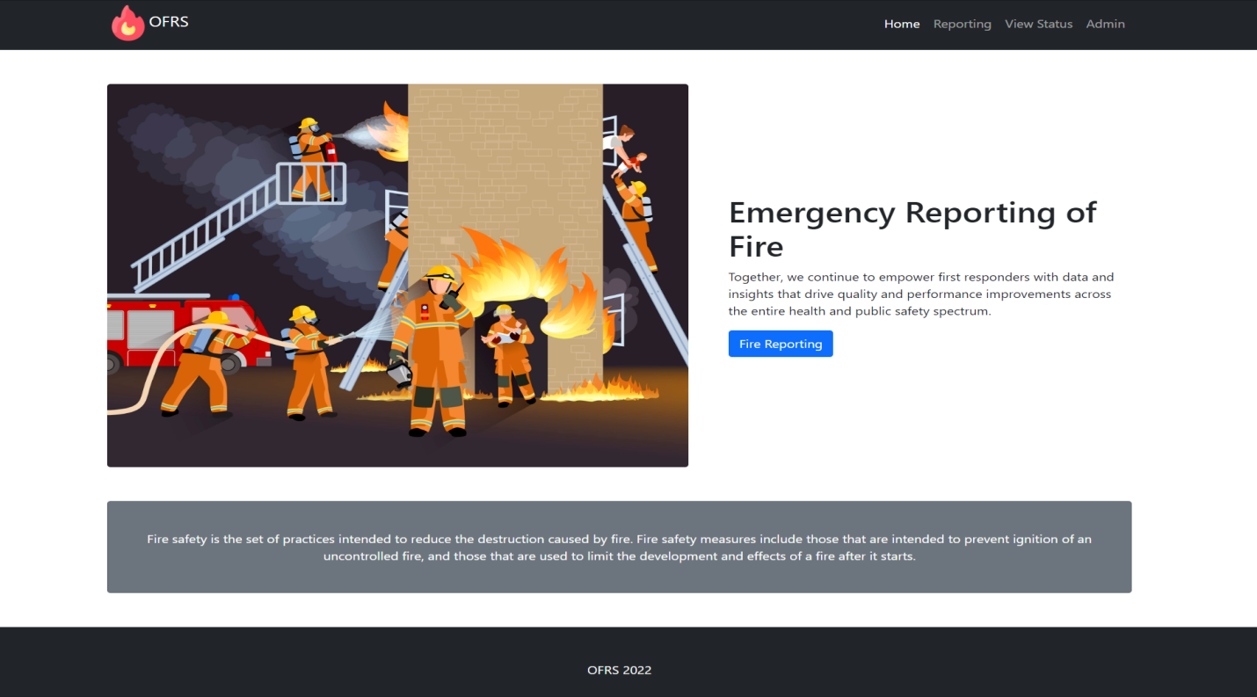

#### Fig 6.1.1 Home Page

Selecting ‘ABOUT AINsoft’, we are taken to the About Us page of the system.

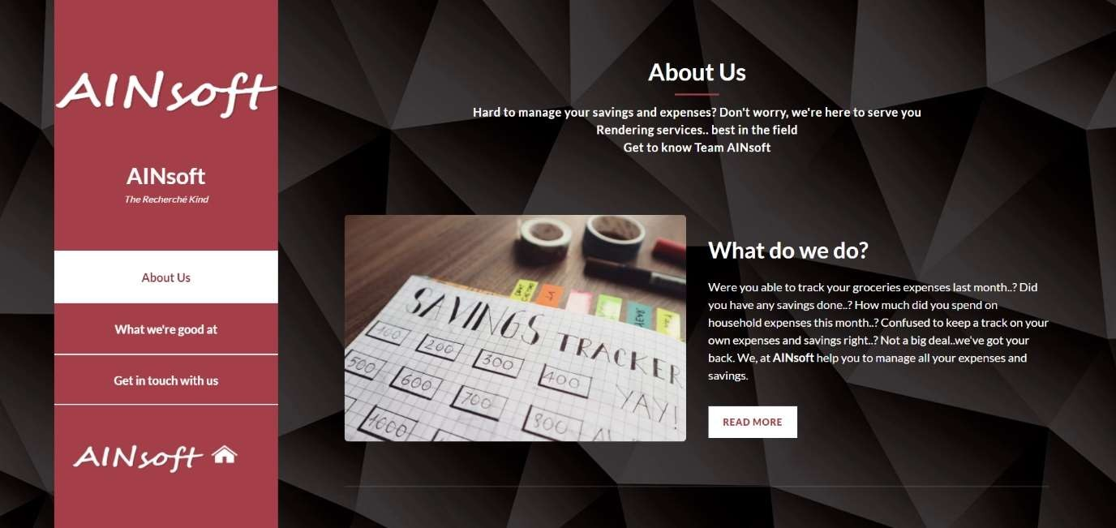

#### Fig 6.1.2 About Us Page

* 1. **The User Login and New User Registration page**

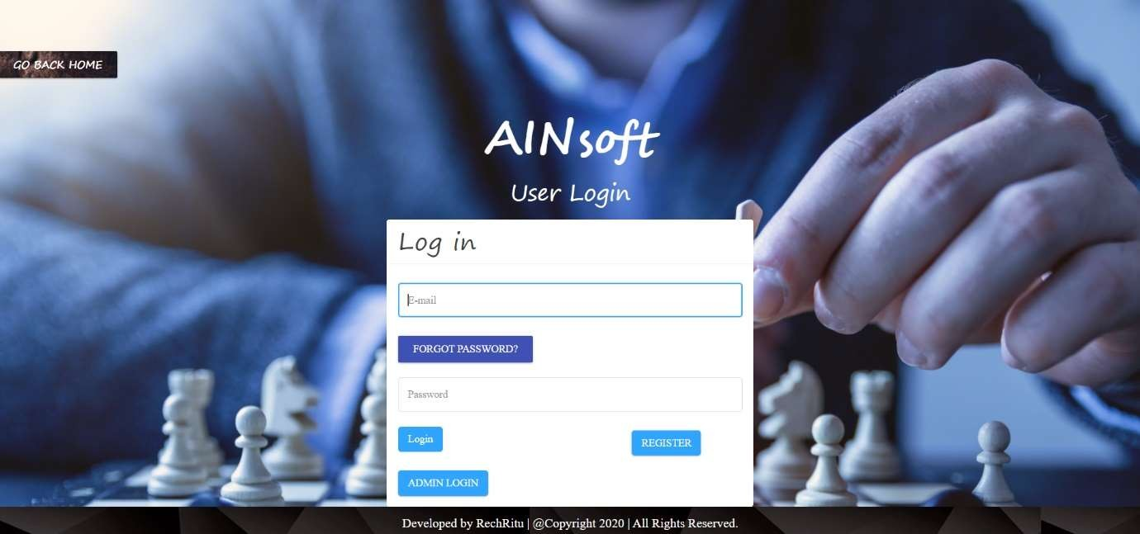

#### Fig 6.2.1 User Login Page

Registered users can login with the ‘Login’ page, and new users can get themselves registered by clicking on ‘New User Register’

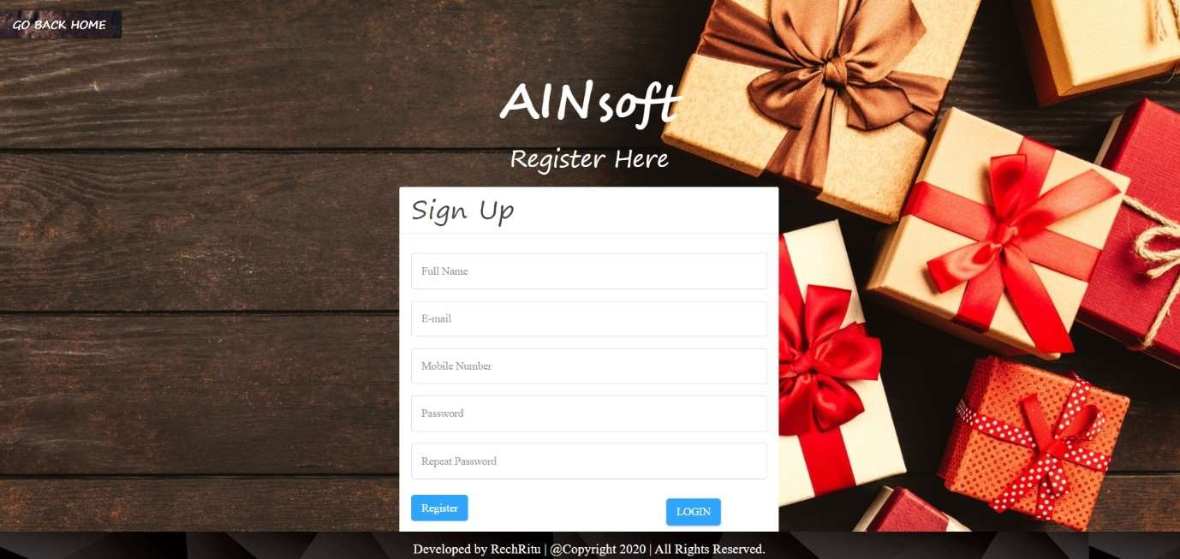

#### Fig 6.2.2 New User Registration Page

* 1. **Forgot Password page and Password Reset page**

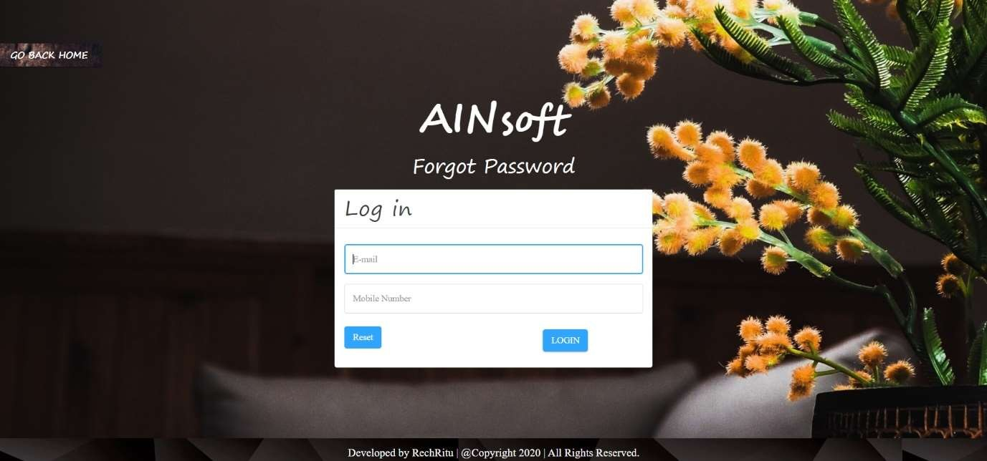

#### Fig 6.3.1 Forgot Password page

In order to reset the password users have to provide their mail id and mobile no.

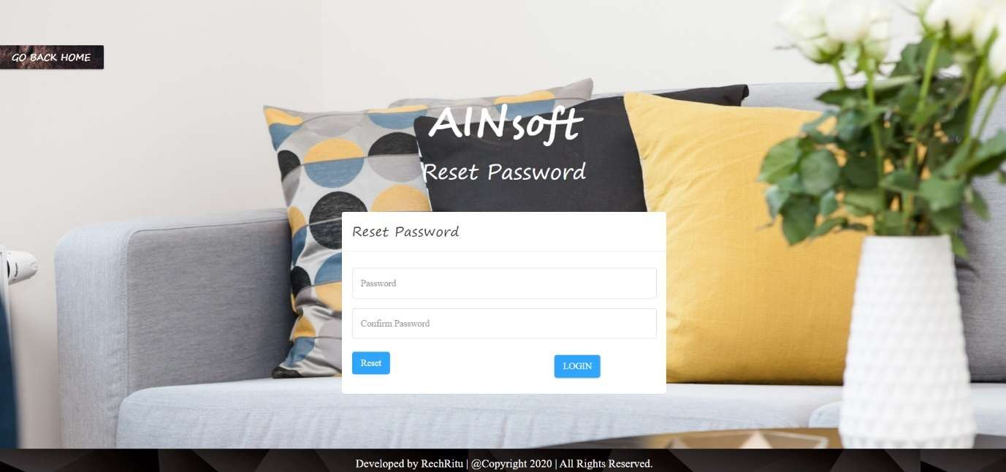

#### Fig 6.3.2 Password Reset page

* 1. **User Dashboard and User Profile page**

.To see all the activities we have user dashboard page

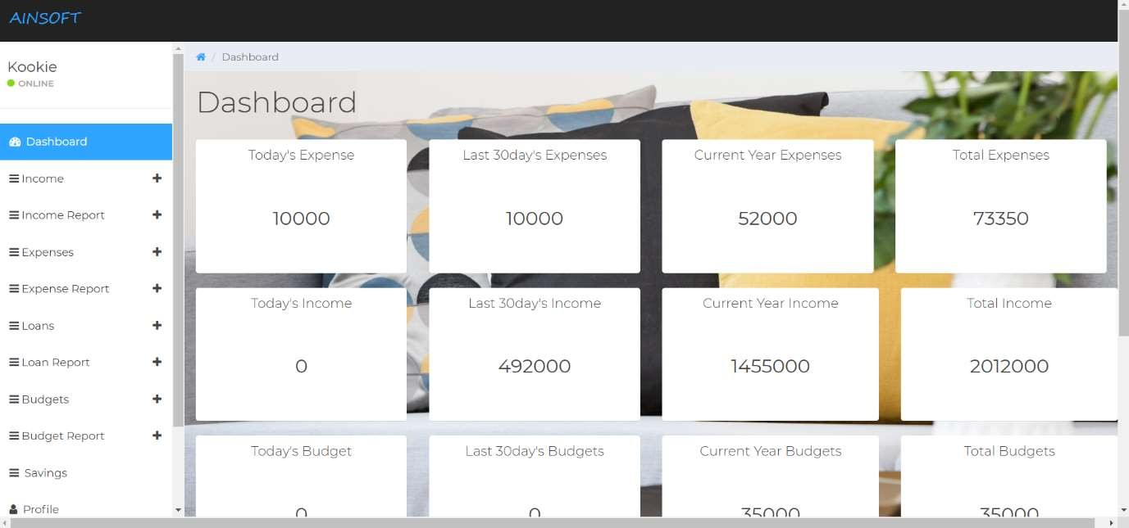

#### Fig 6.4.1 User Dashboard

To view the user profile we have “Profile”

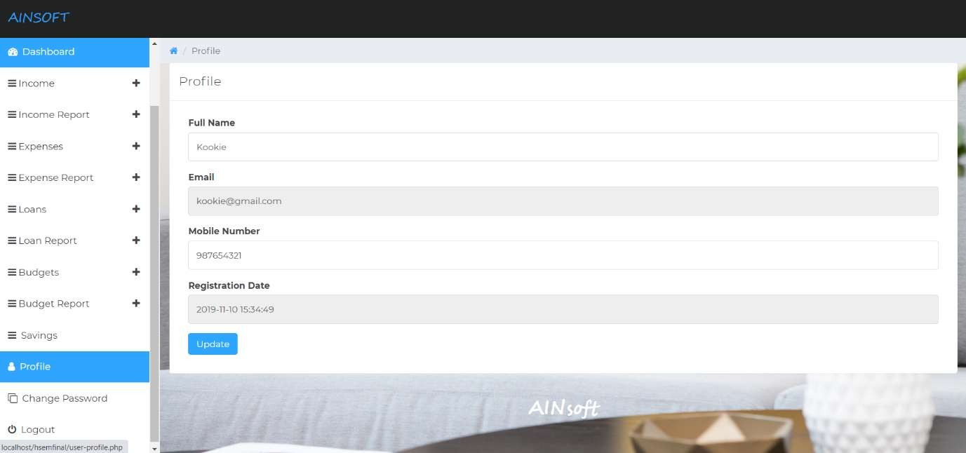

#### Fig 6.4.2 User Profile

* 1. **USER - Insert records and Manage the records**

The users can insert income, expense or any other data and manage those data as well.

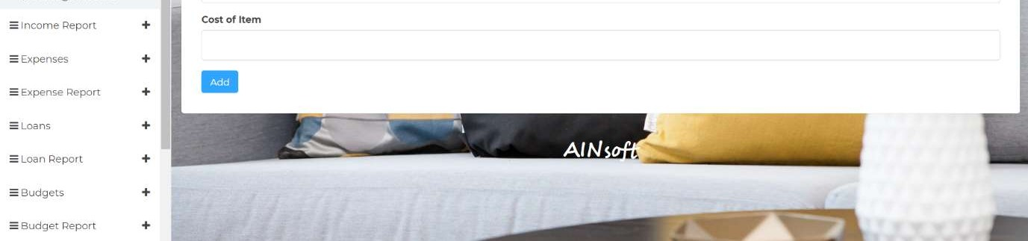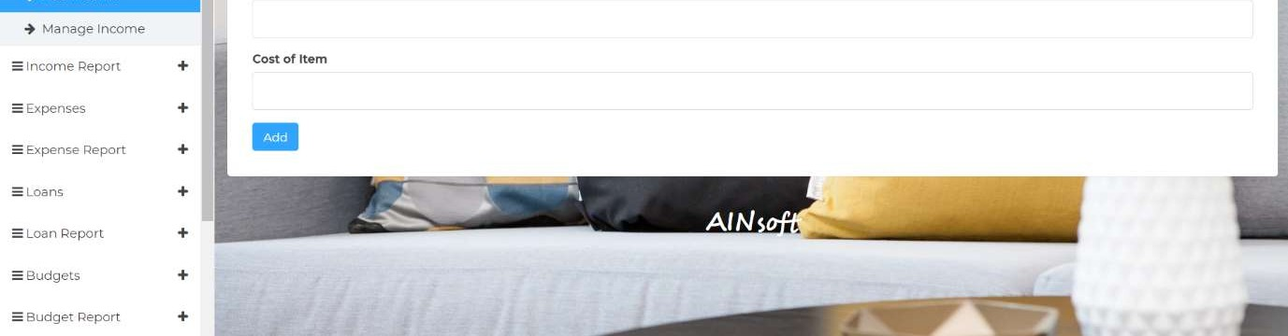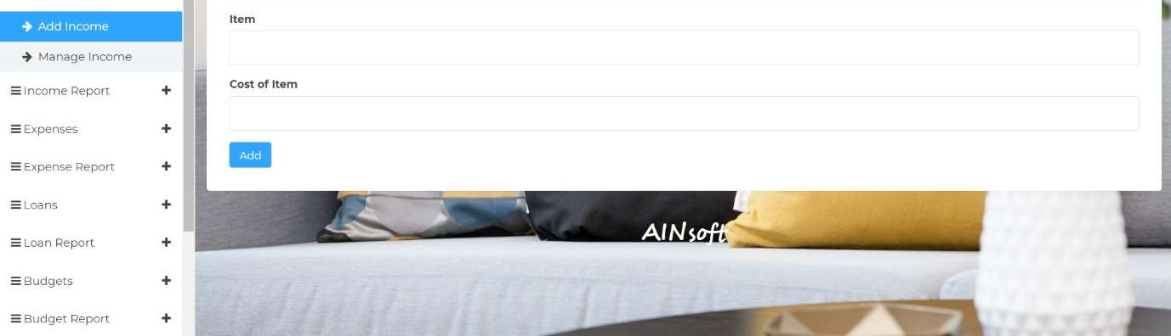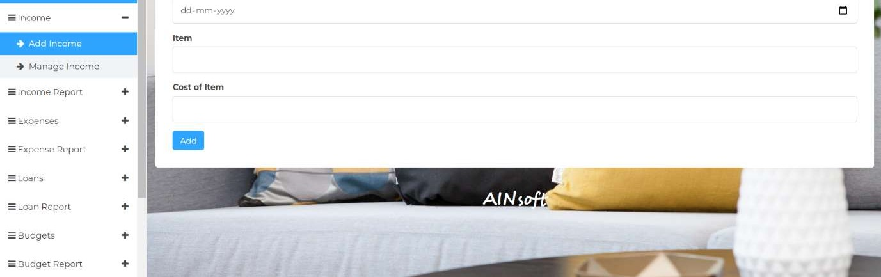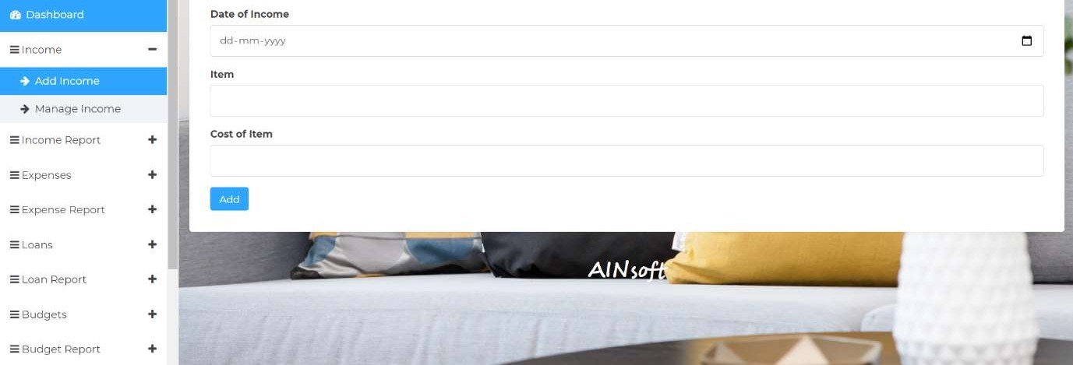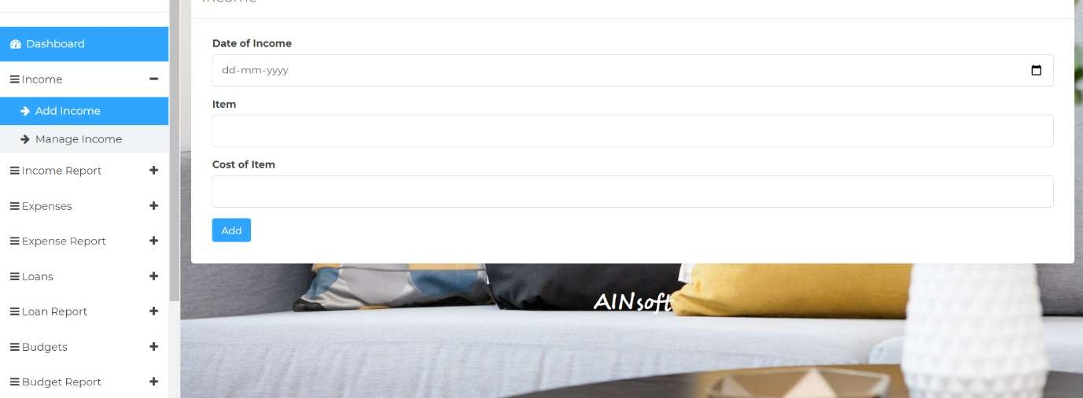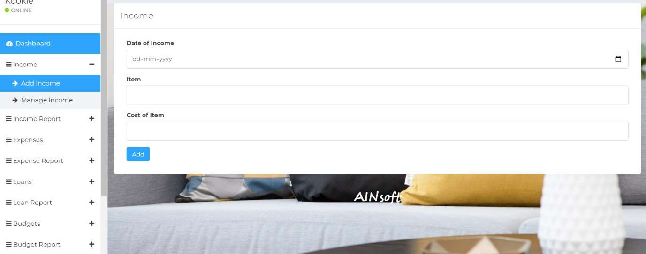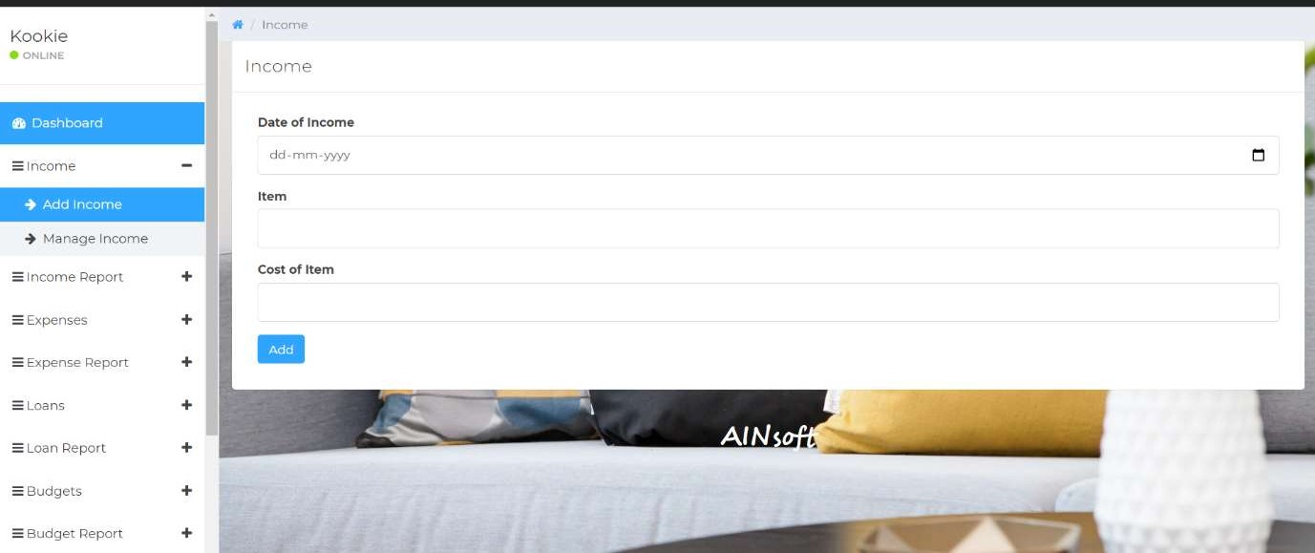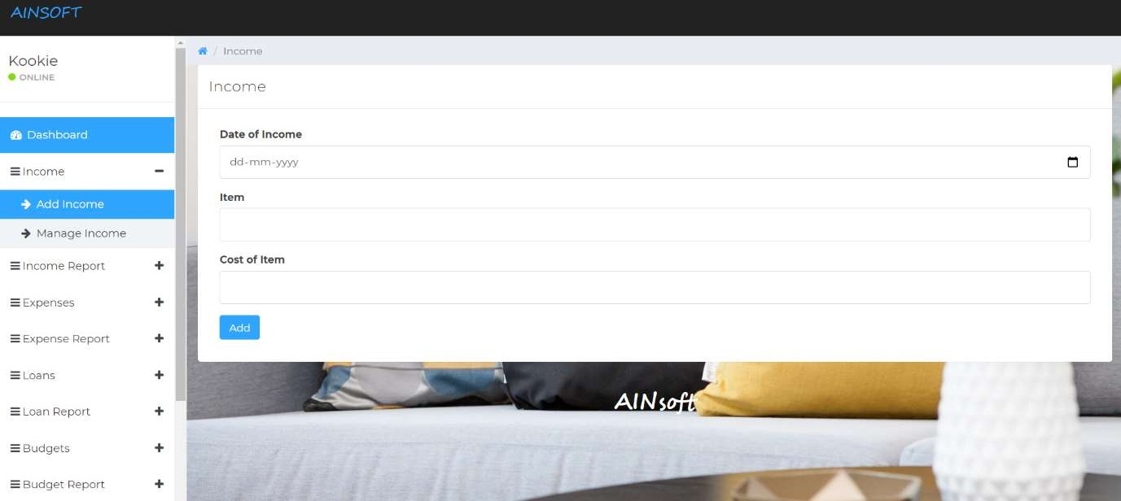

#### Fig 6.5.1 Insert Records

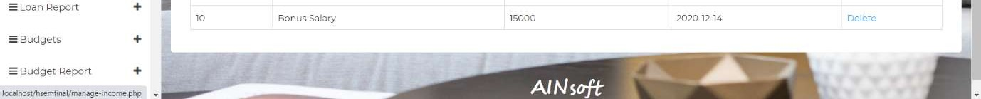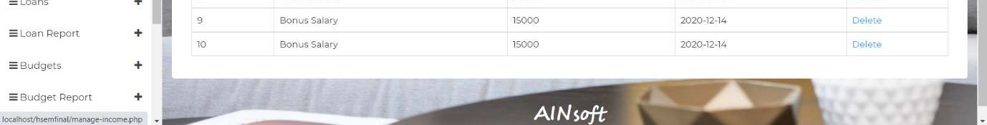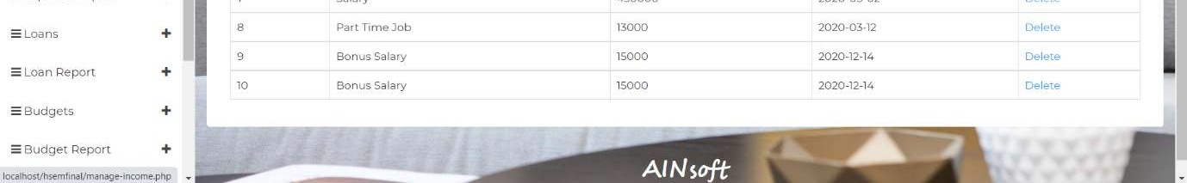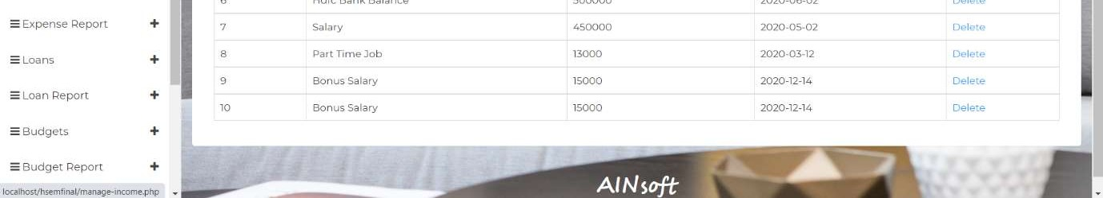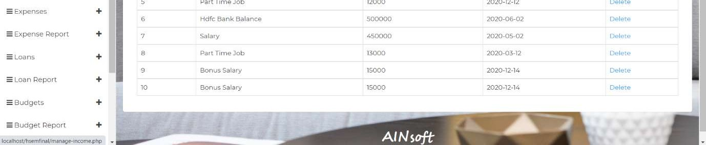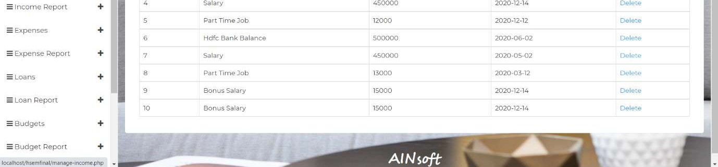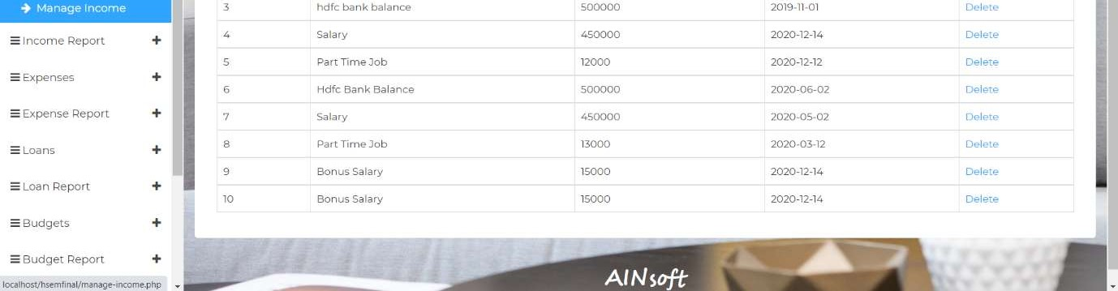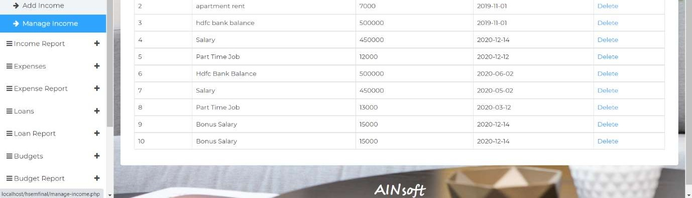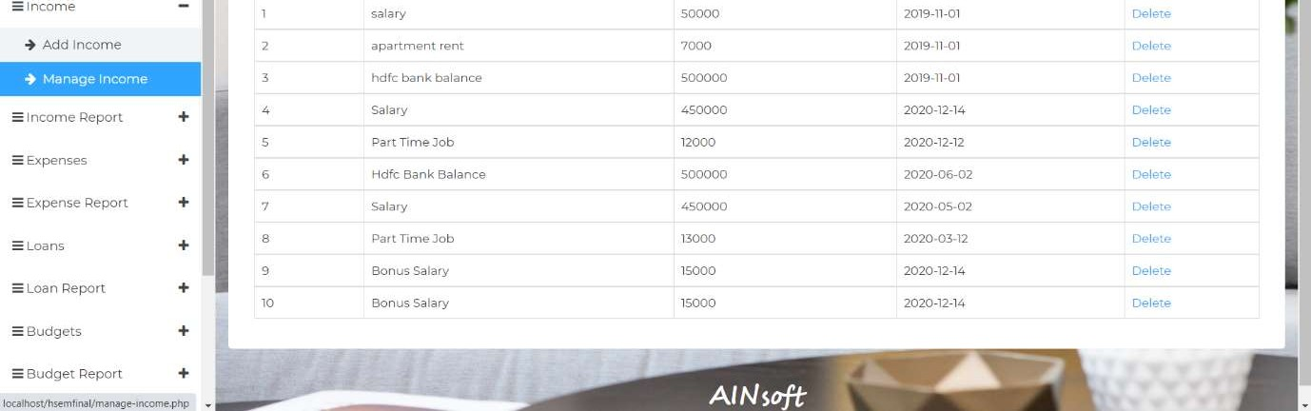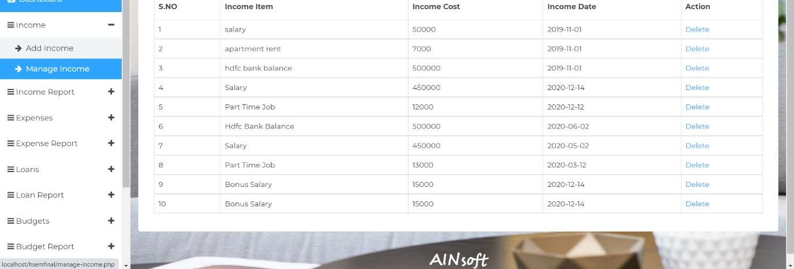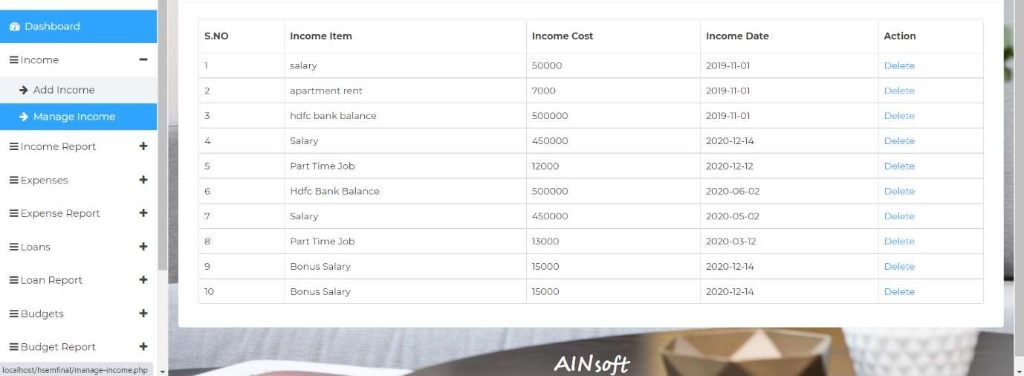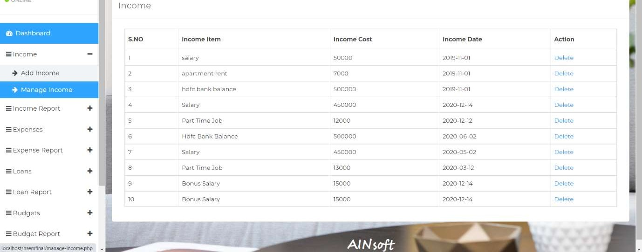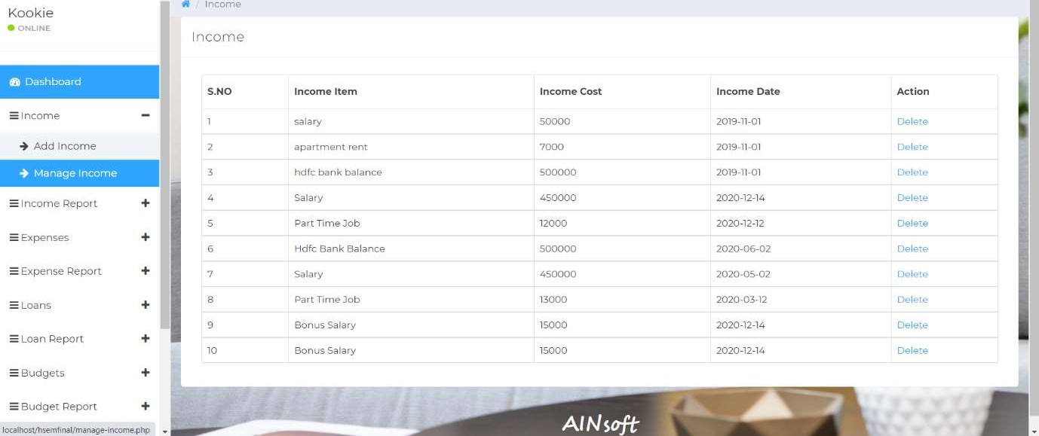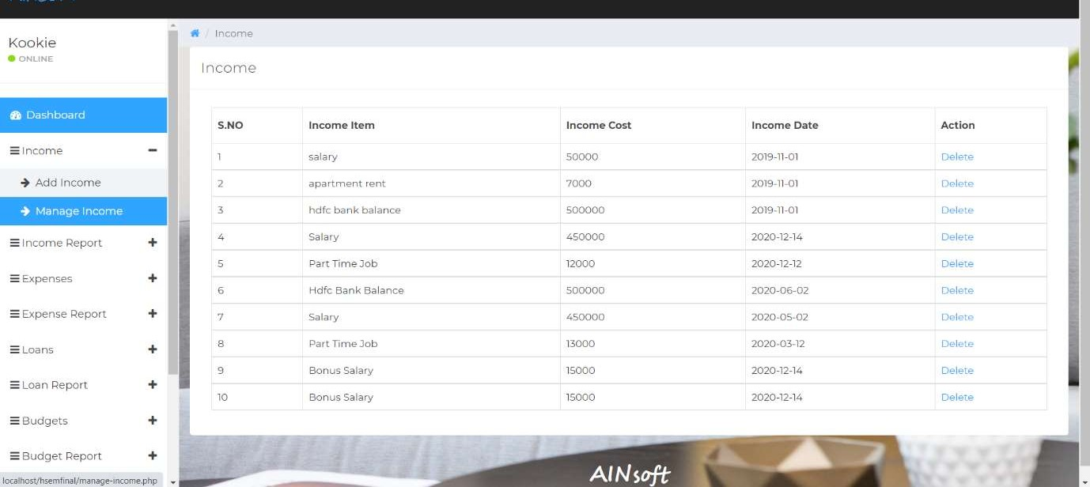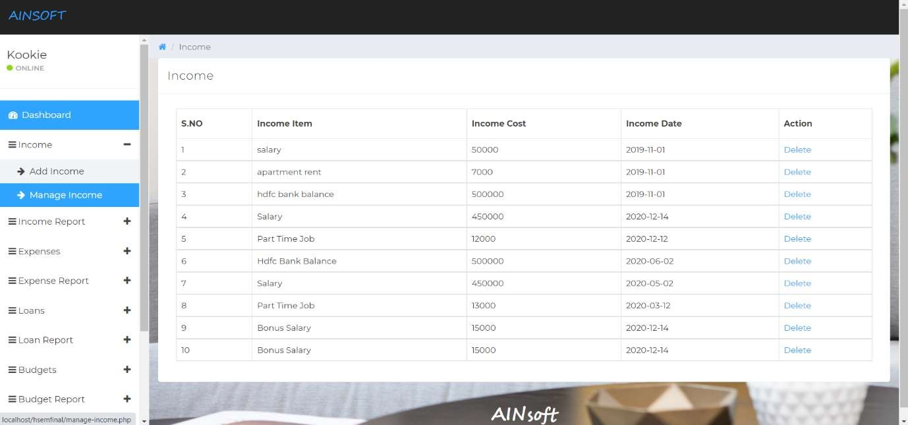

**Fig 6.5.2 Manage Records**

#### USER - View Income Report

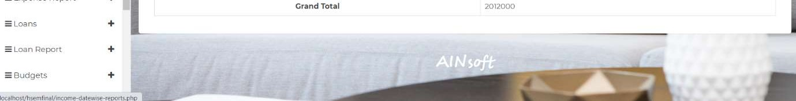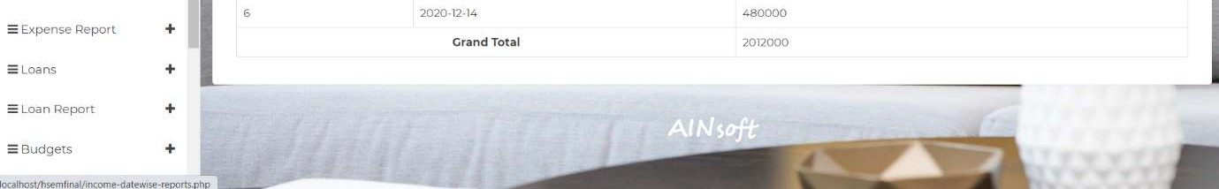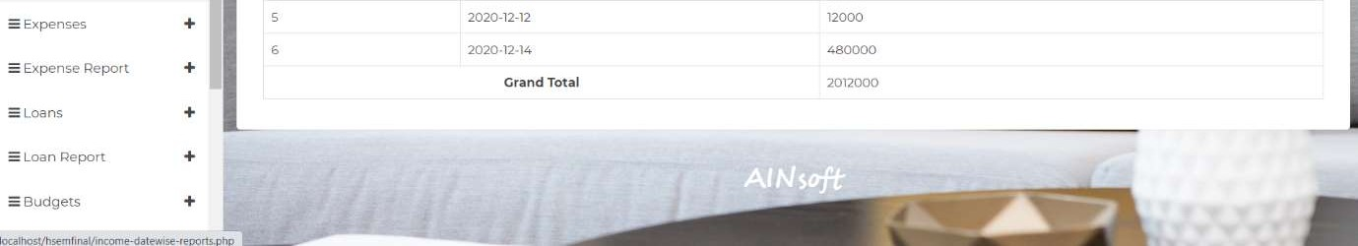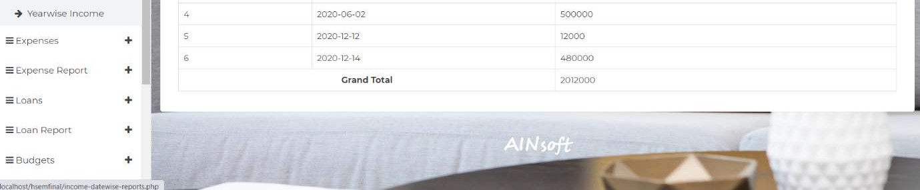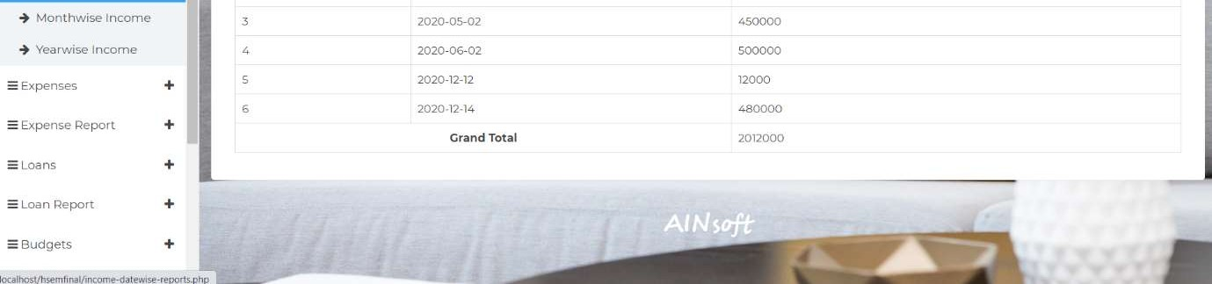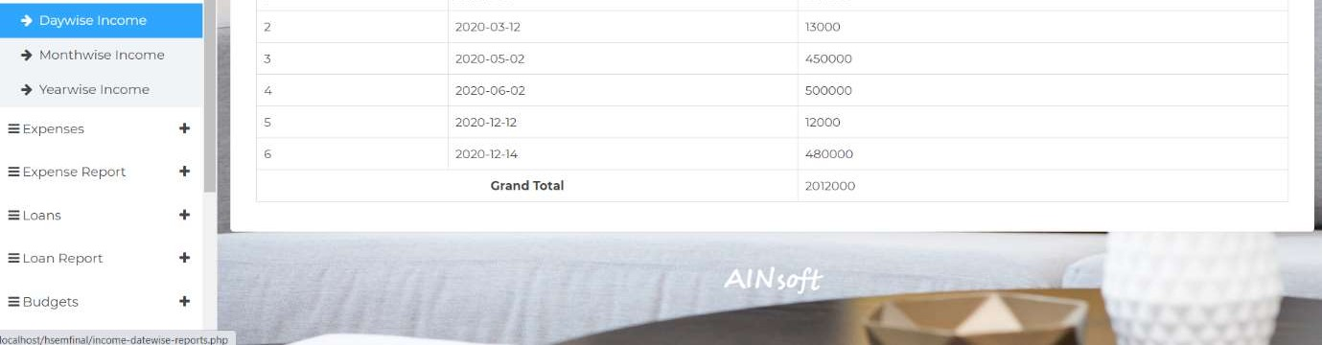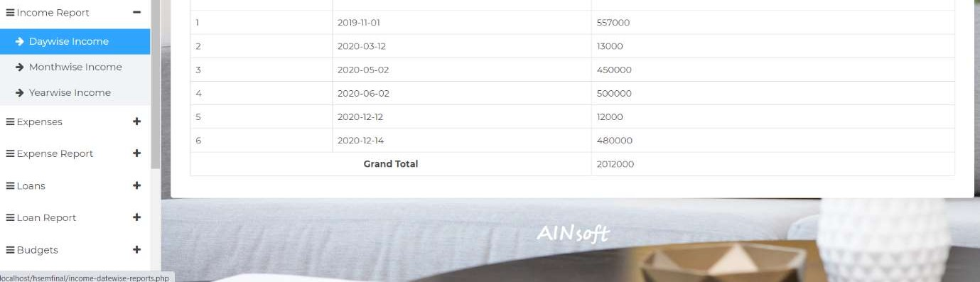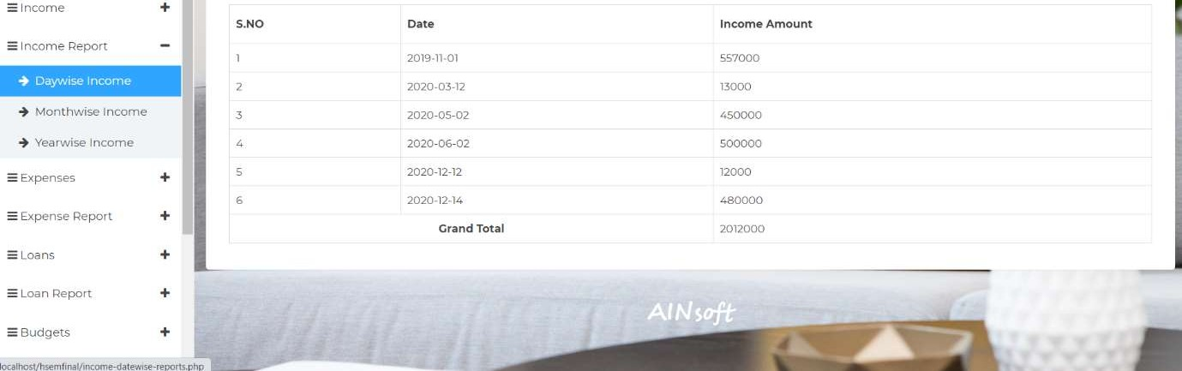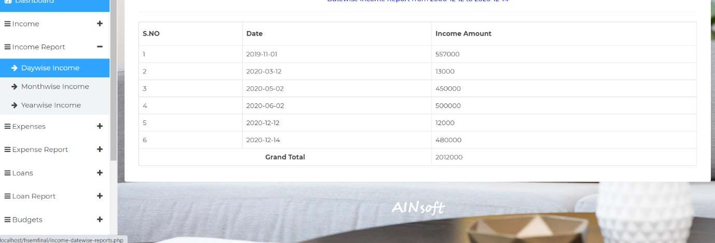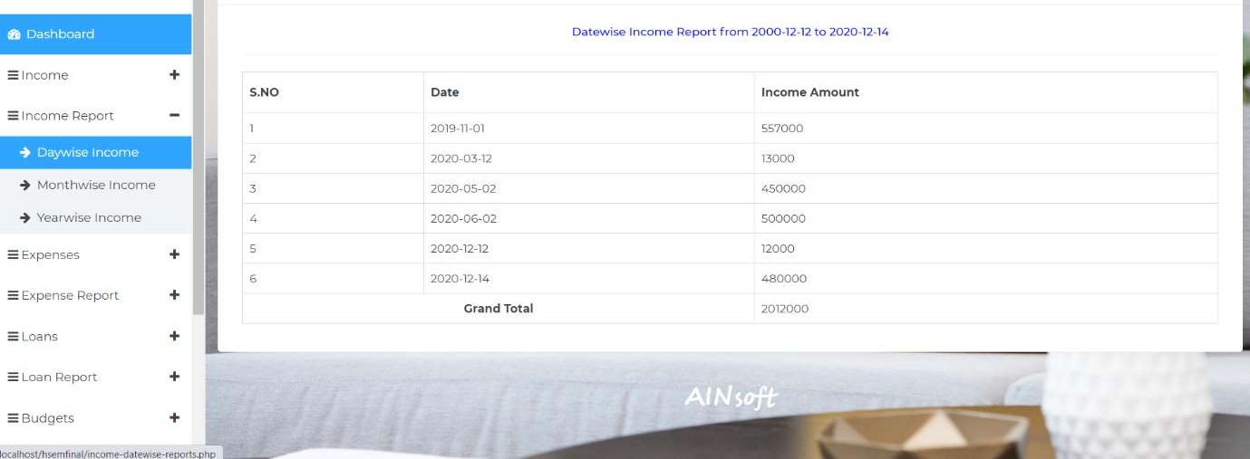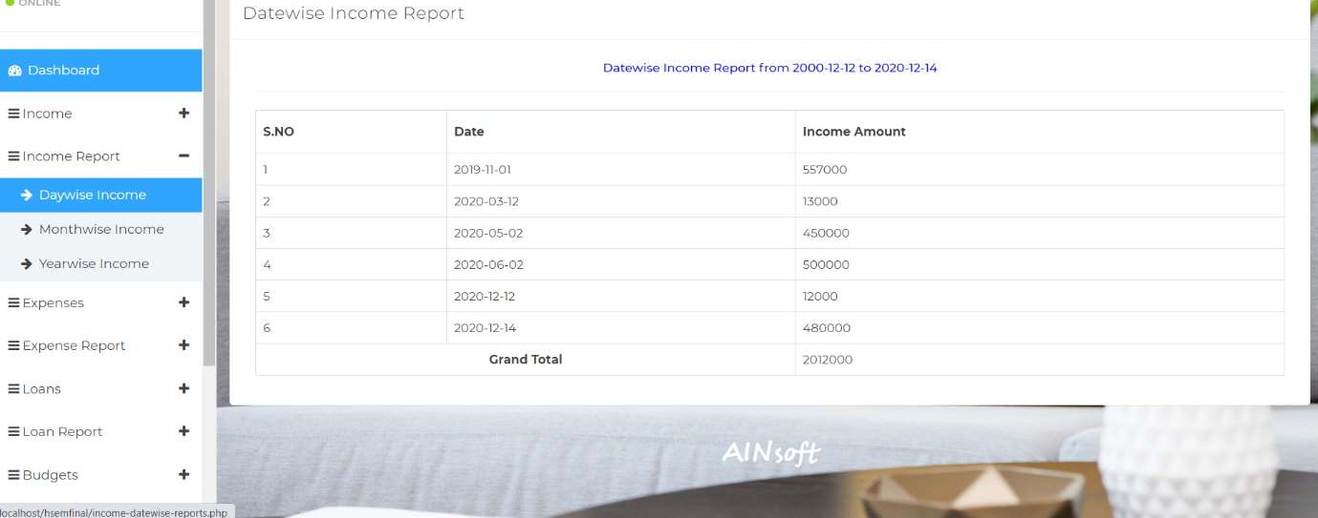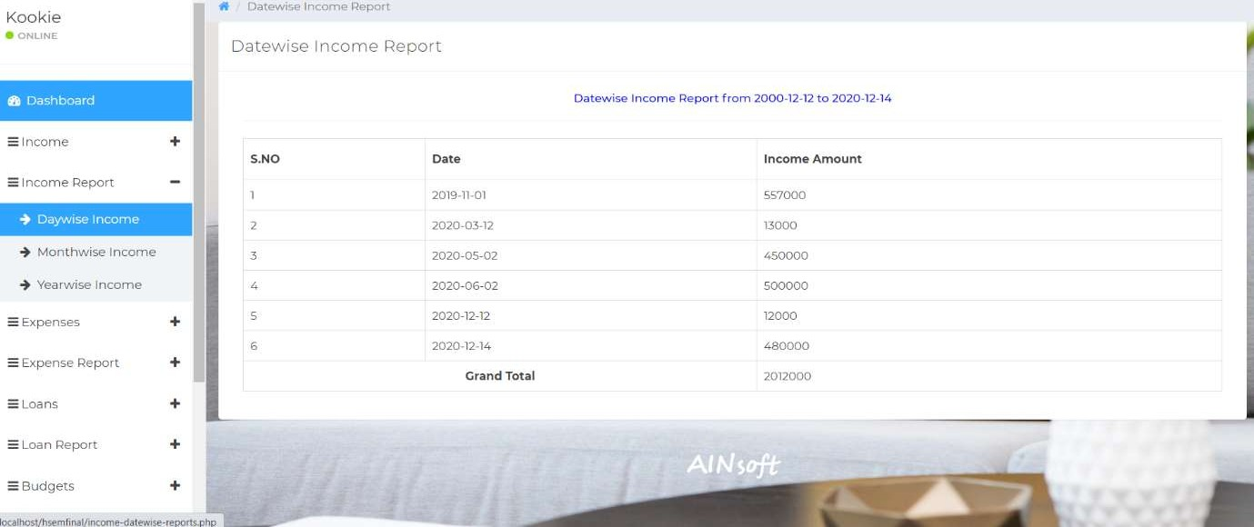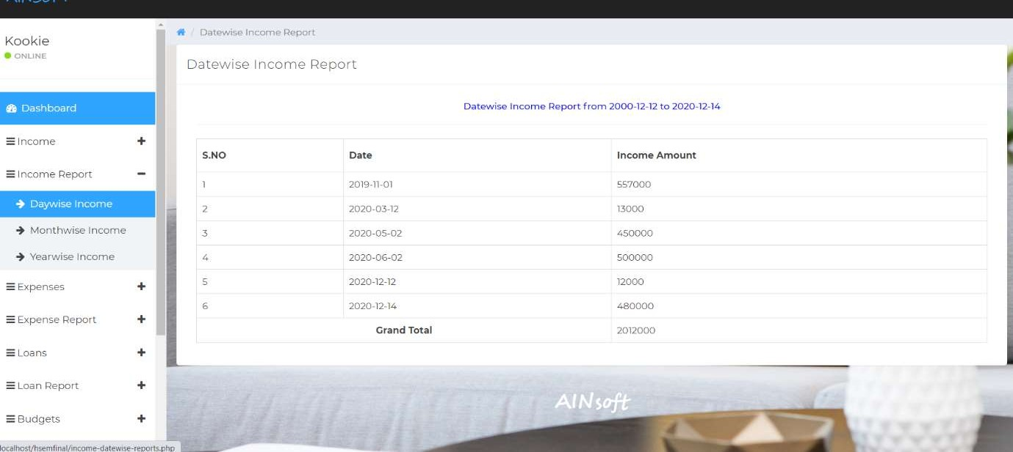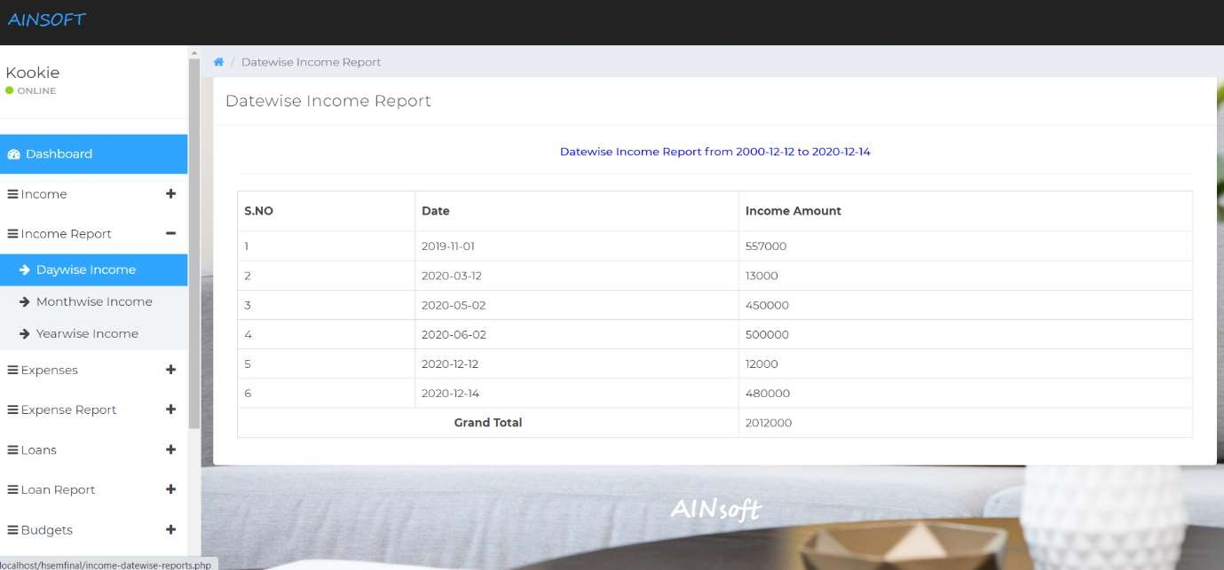

**Fig 6.6.1 View Income Report - Daywise**

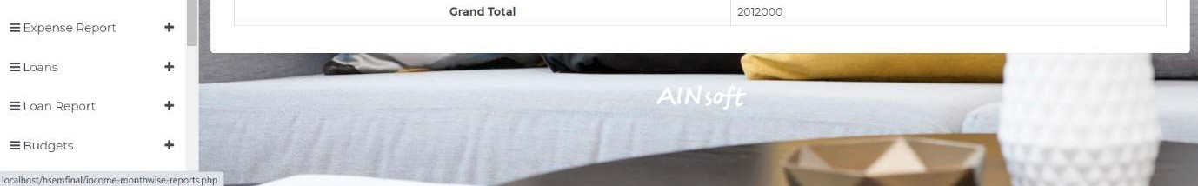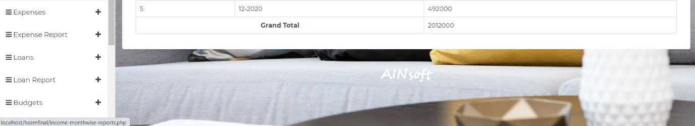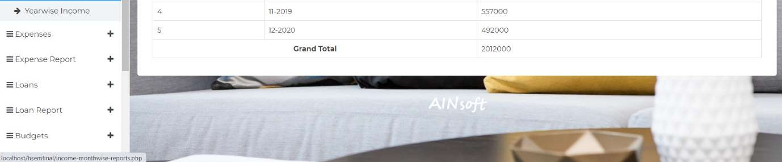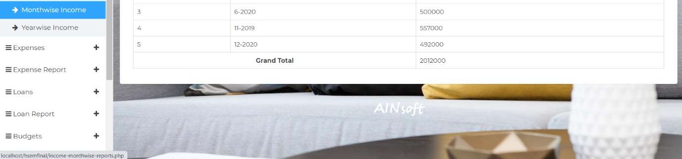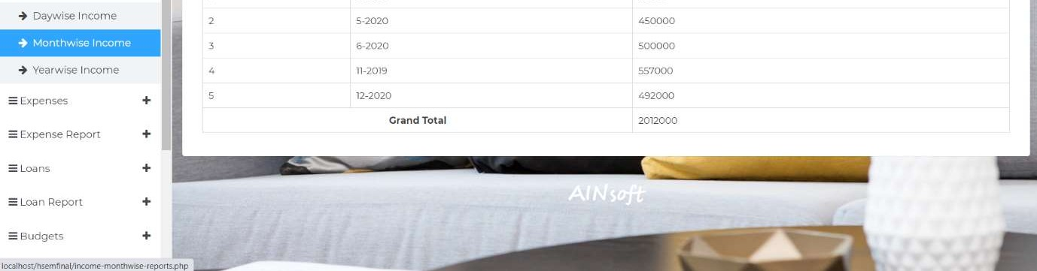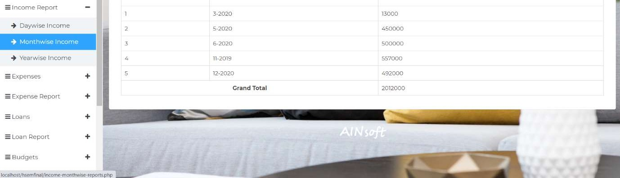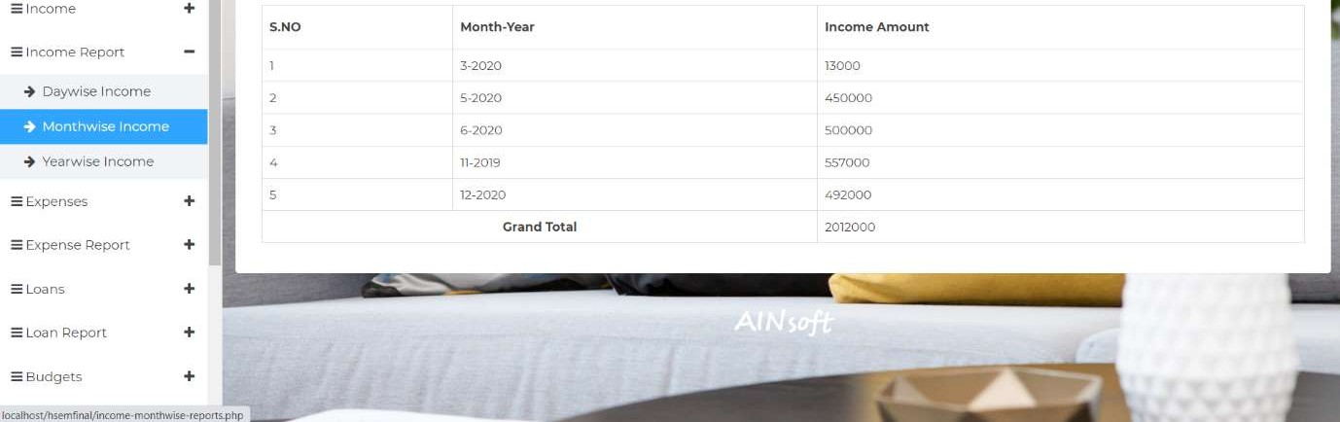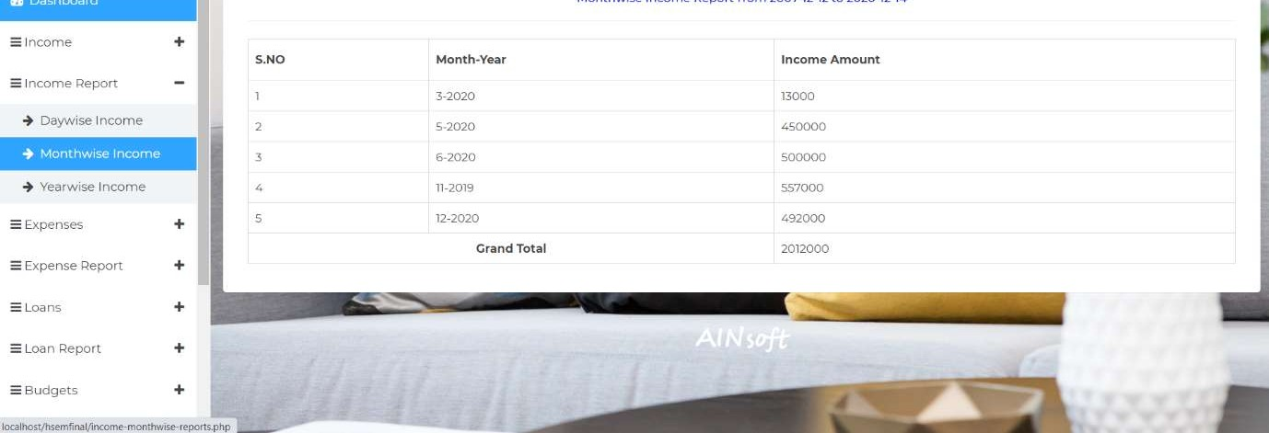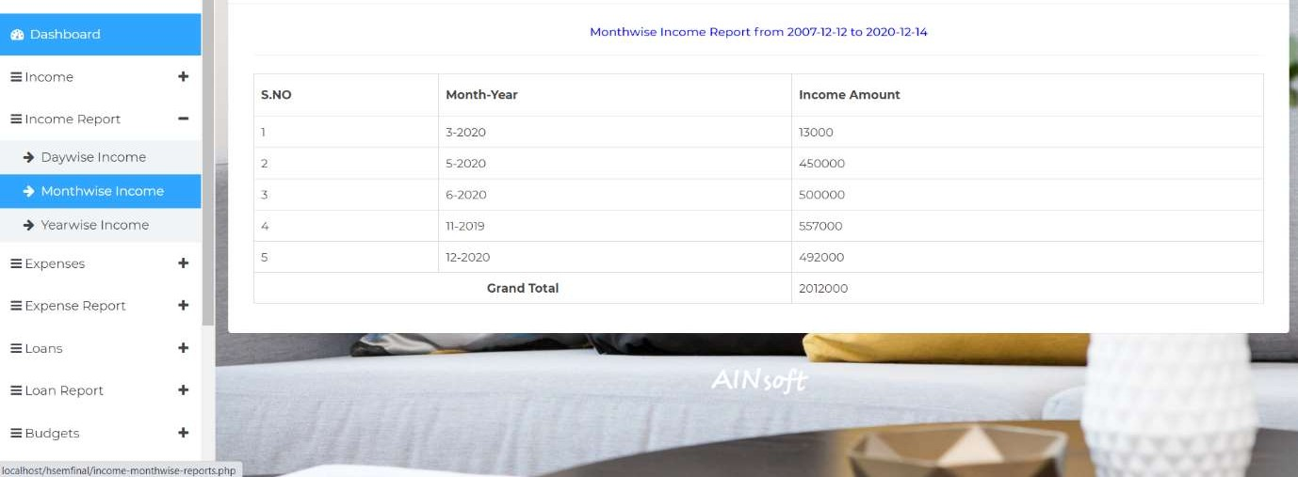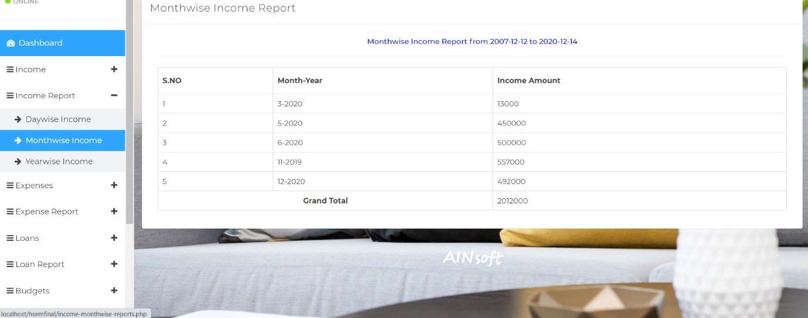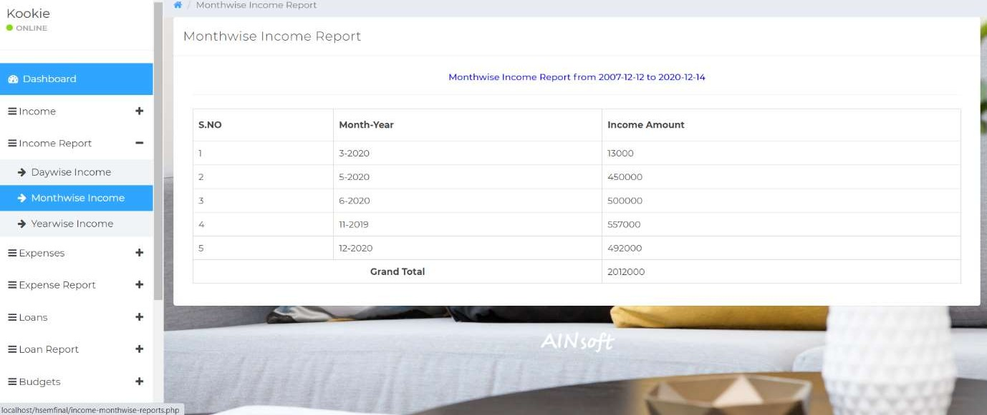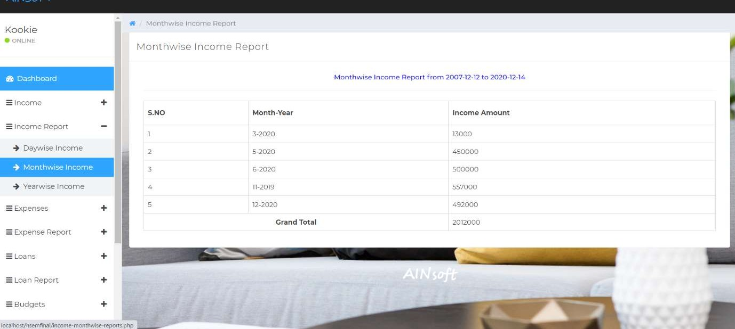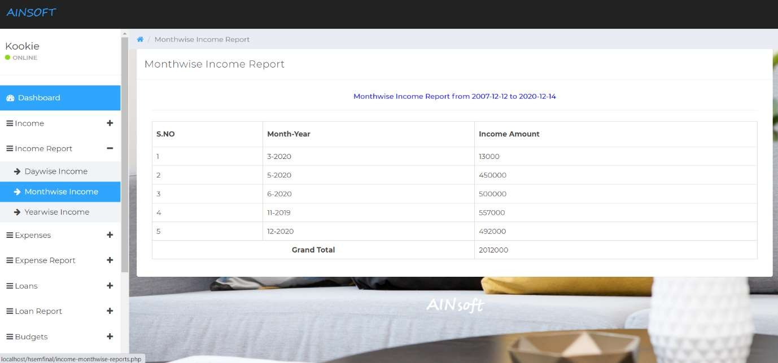

#### Fig 6.6.2 View Income Report - Monthwise

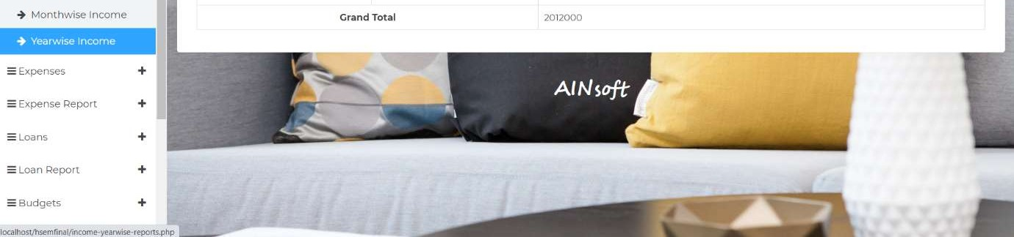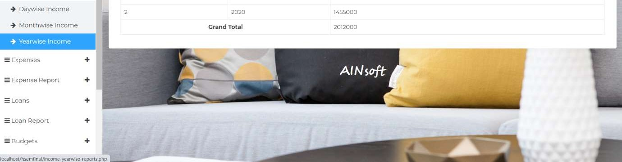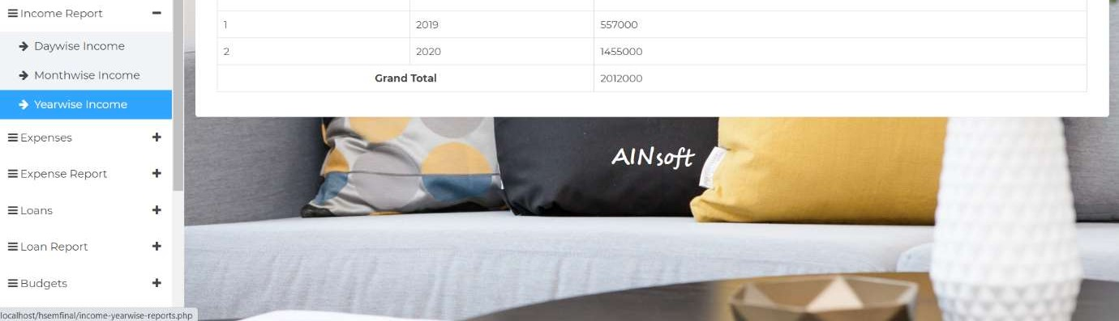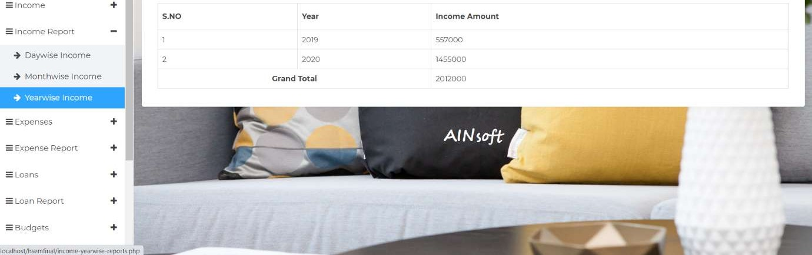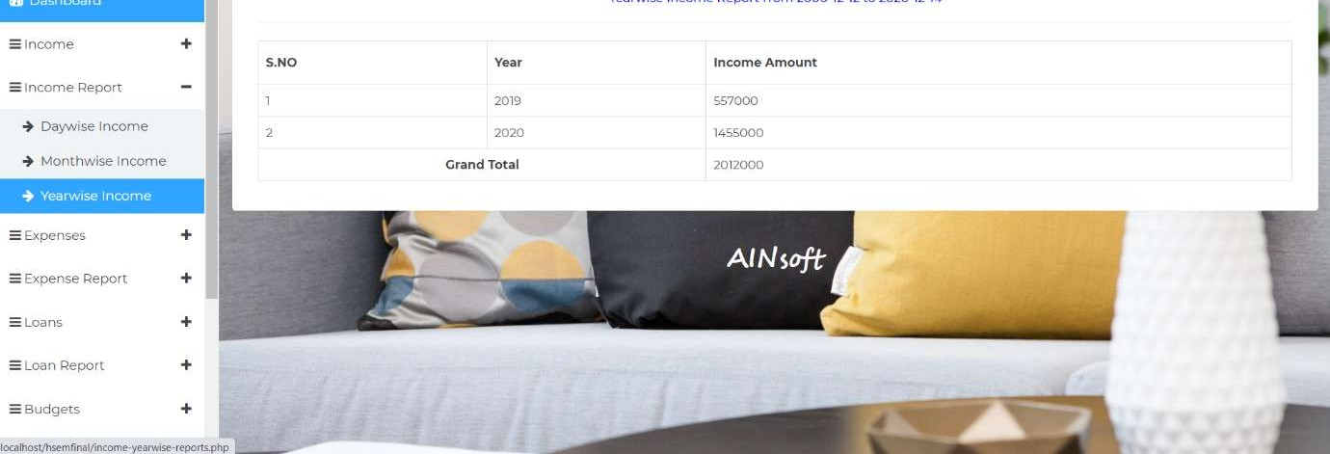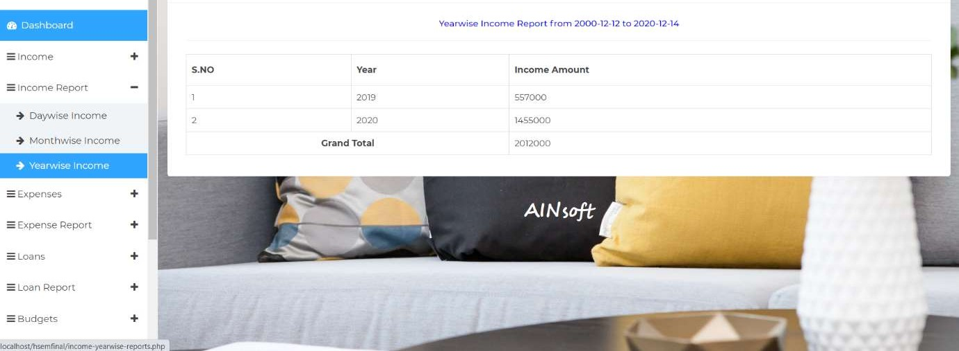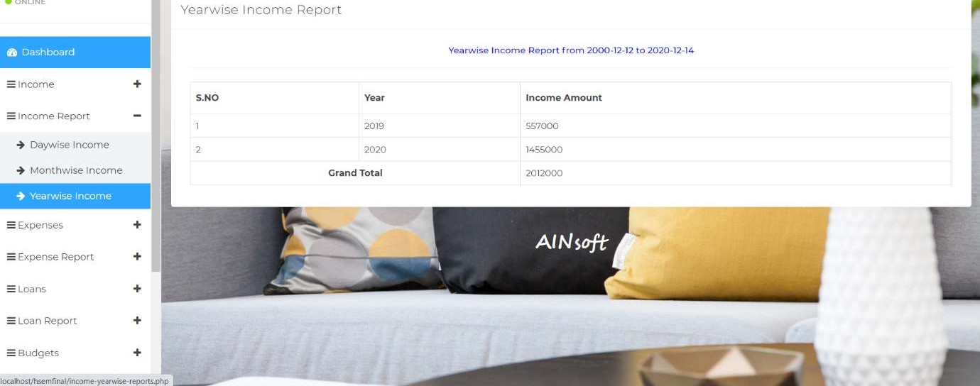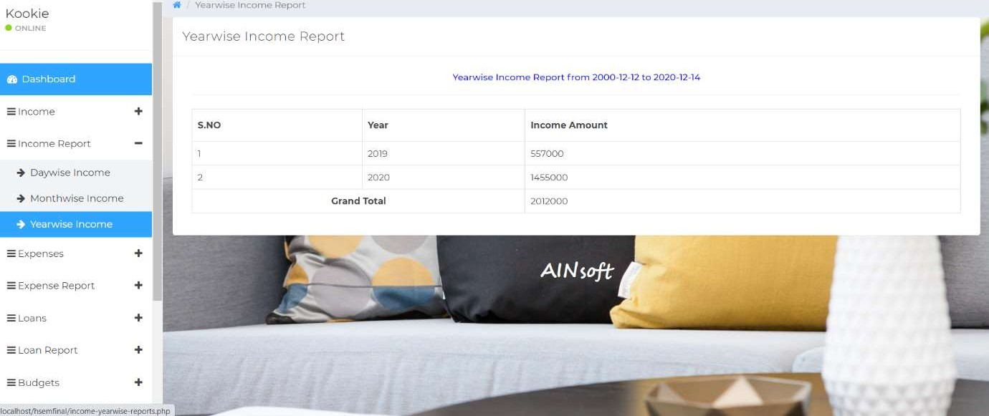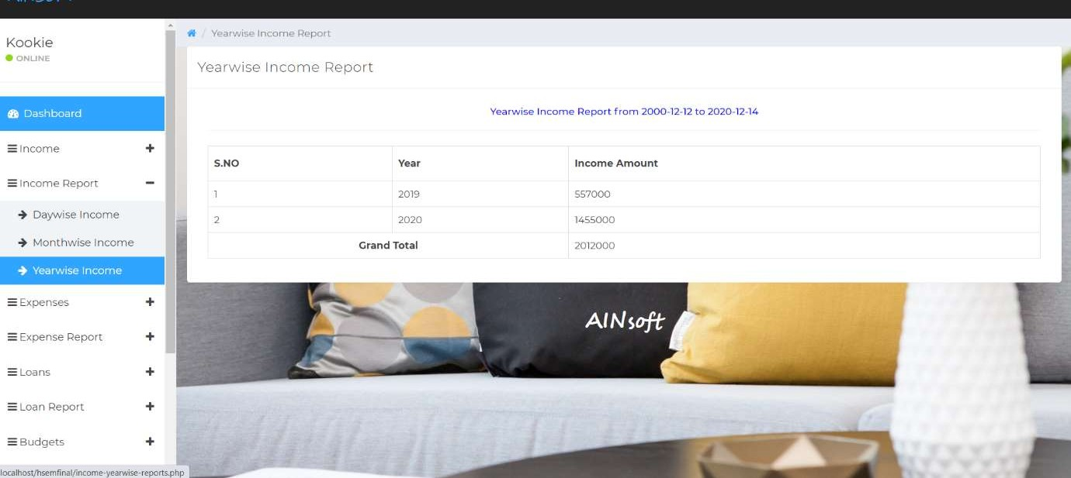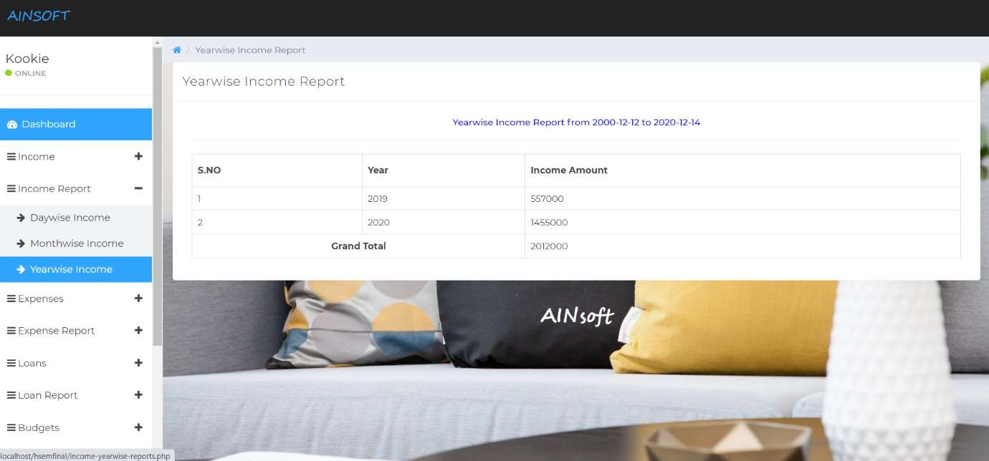

**Fig 6.6.3 View Income Report – Yearwise**

#### USER - View Expense Report

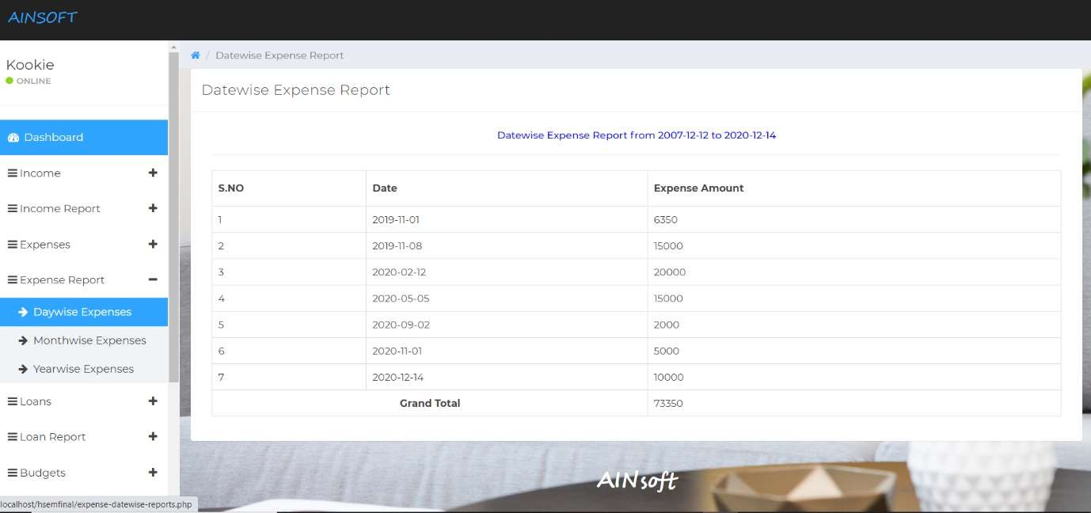

**Fig 6.7.1 View Expense Report - Daywise**

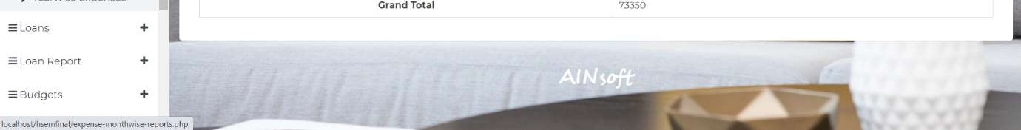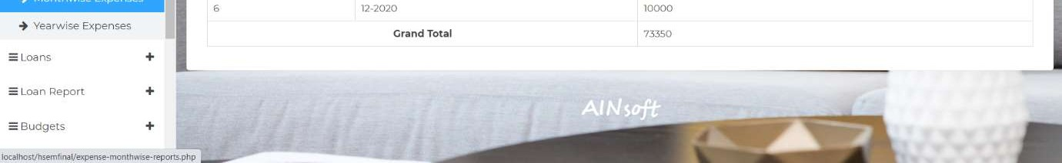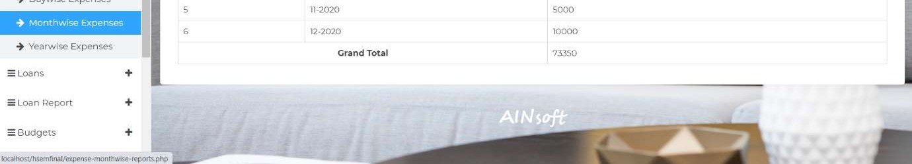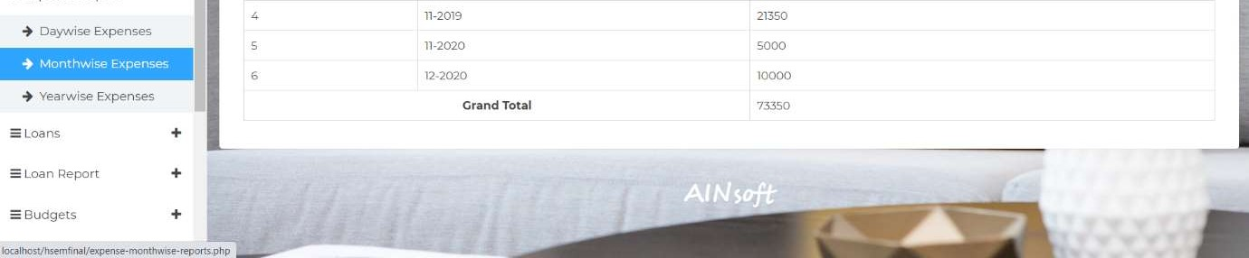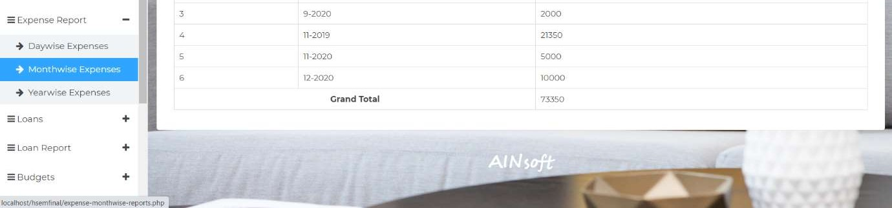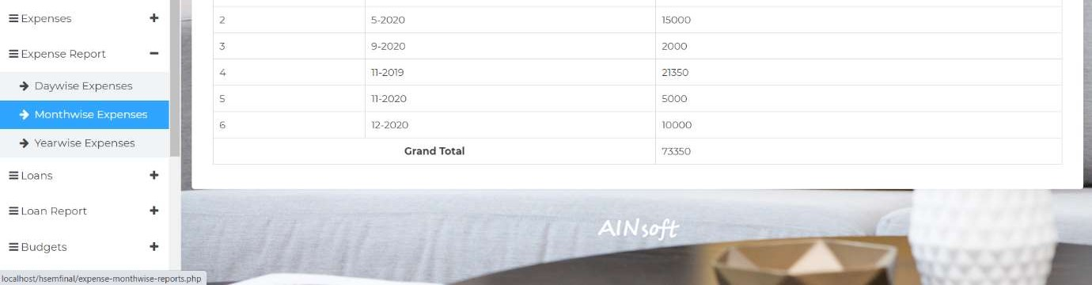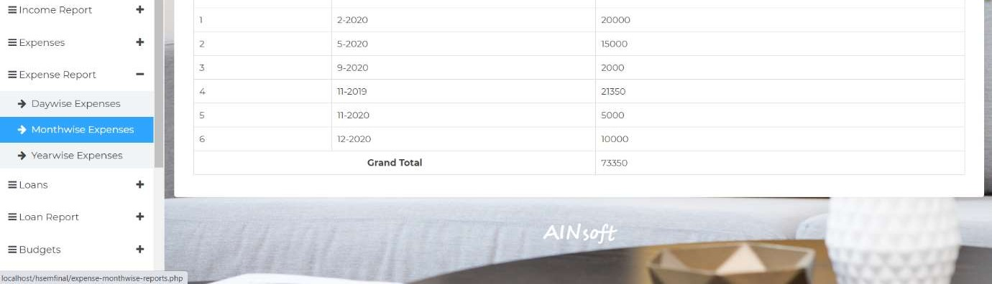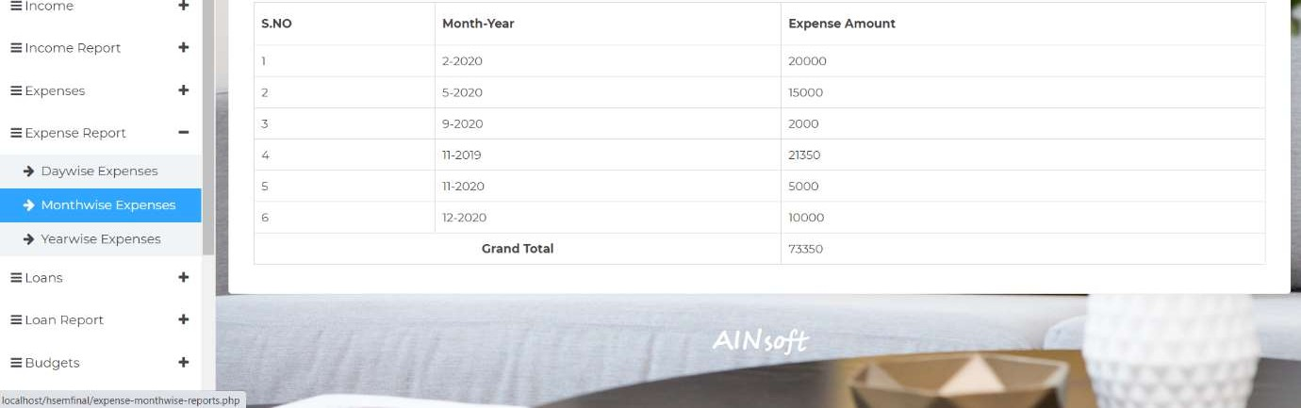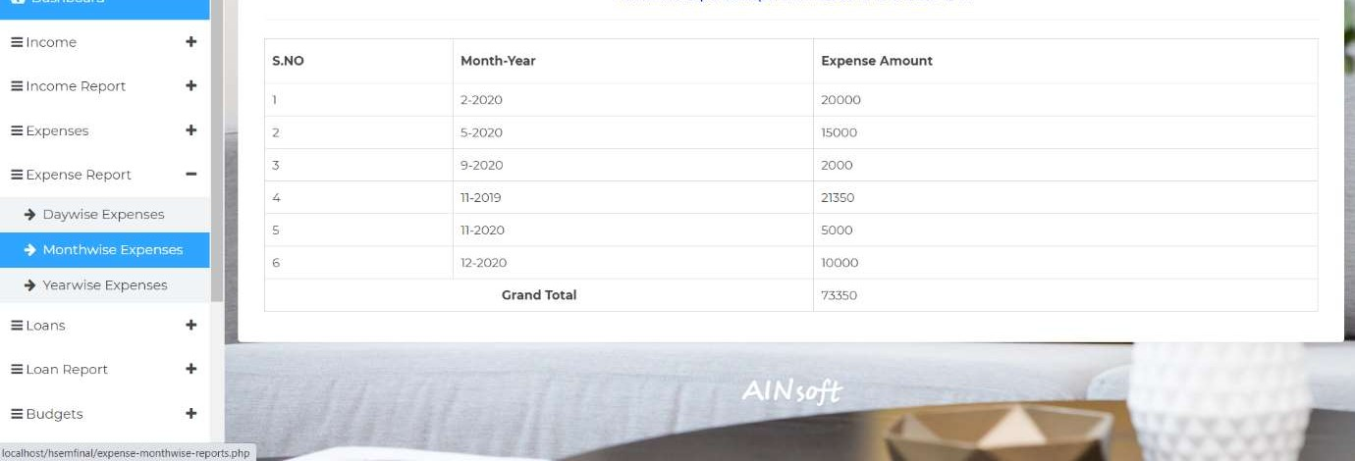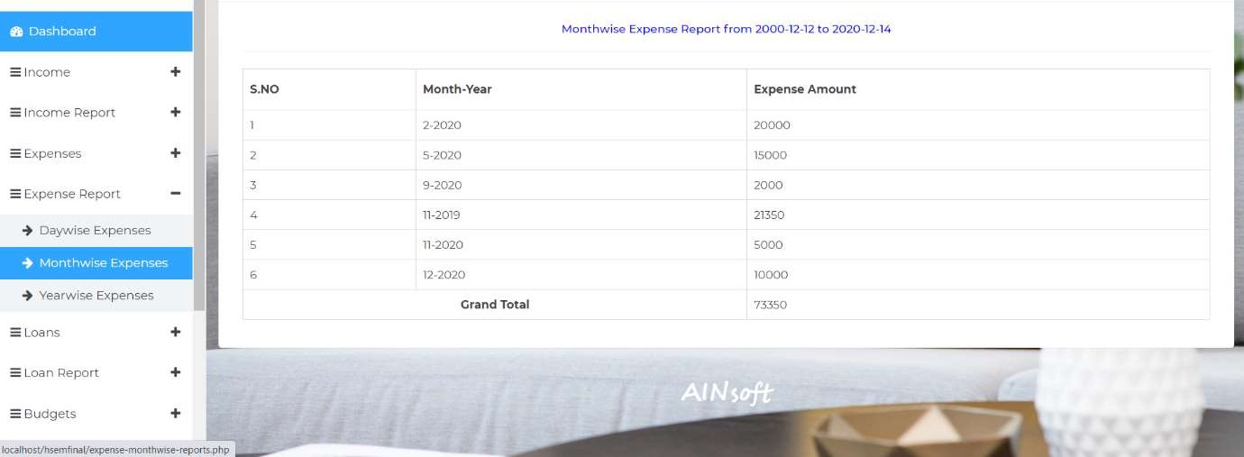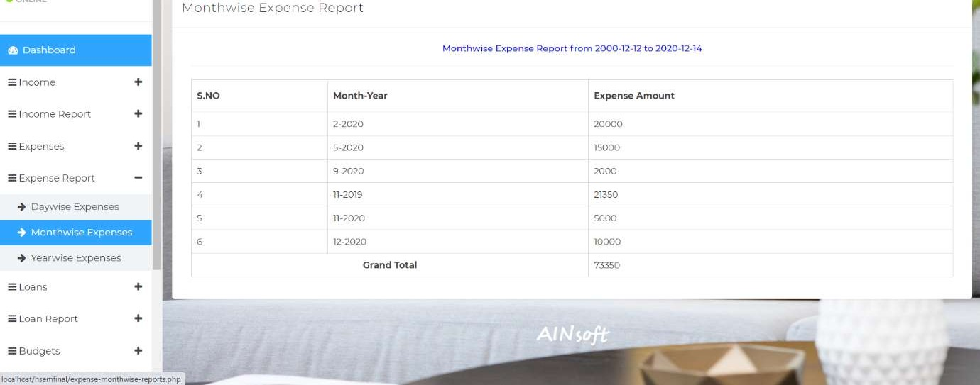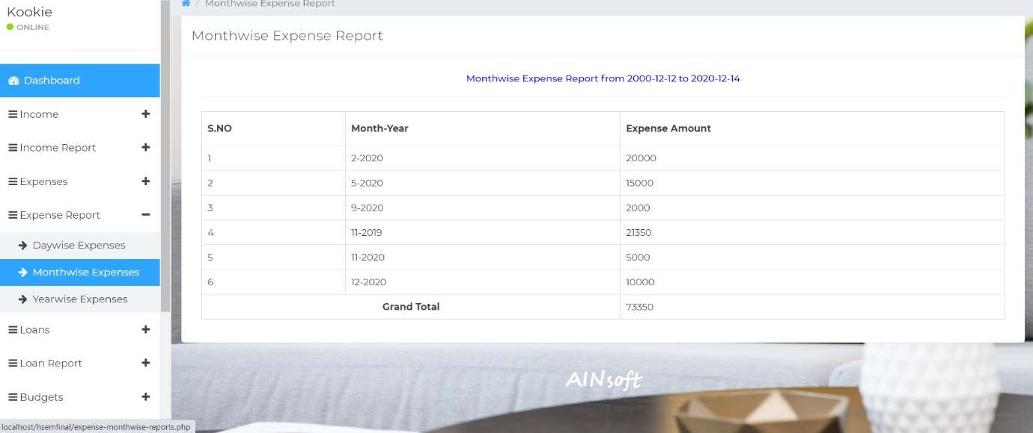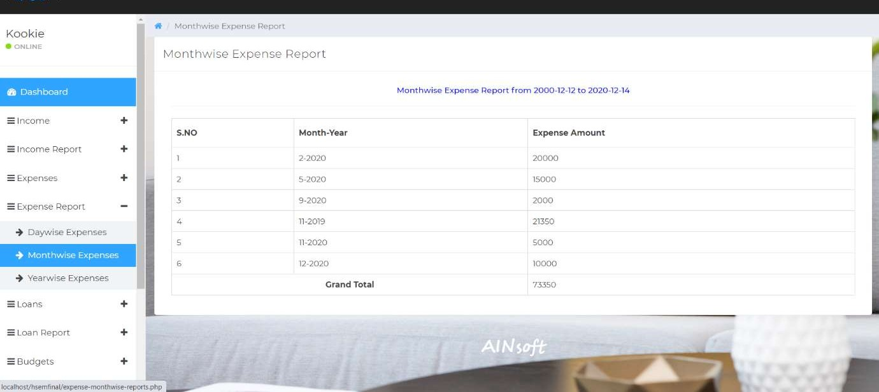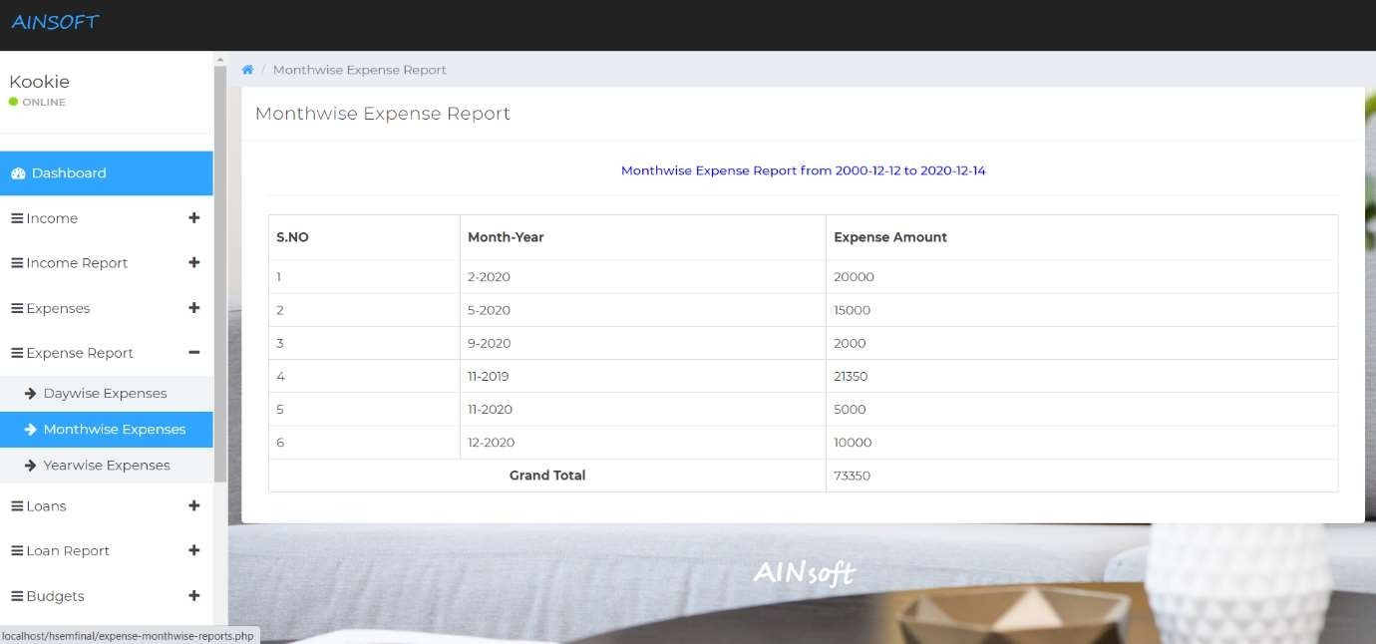

#### Fig 6.7.2 View Expense Report – Monthwise

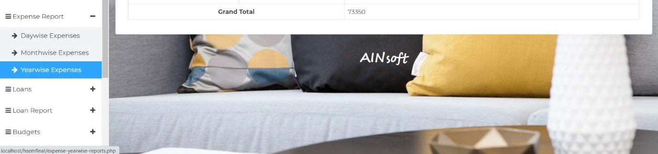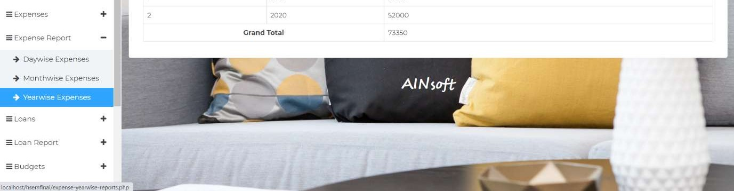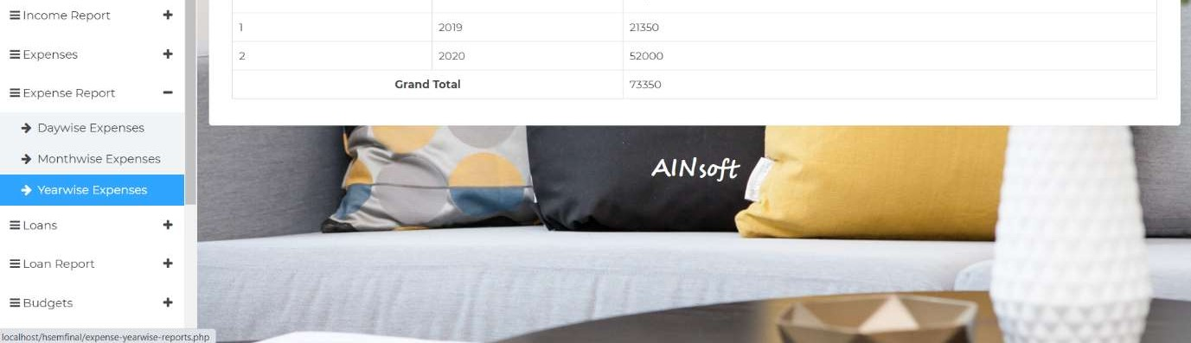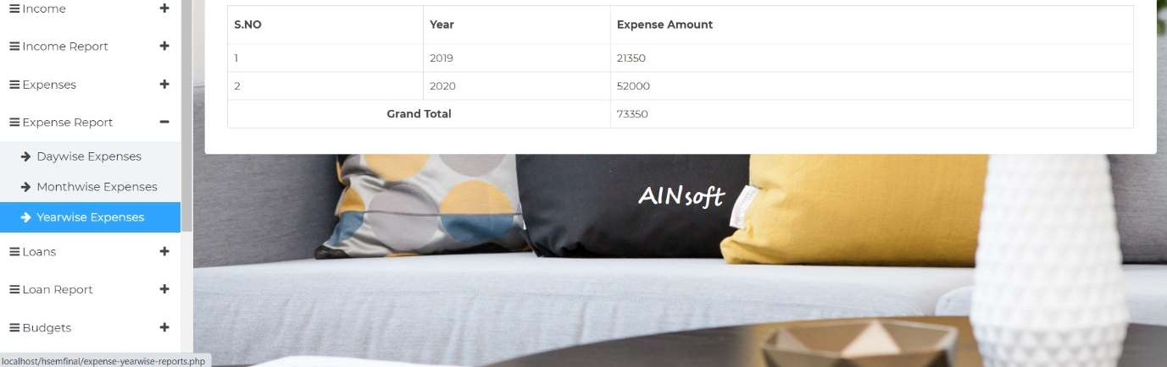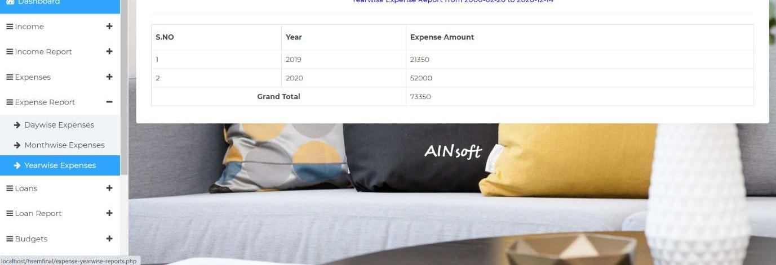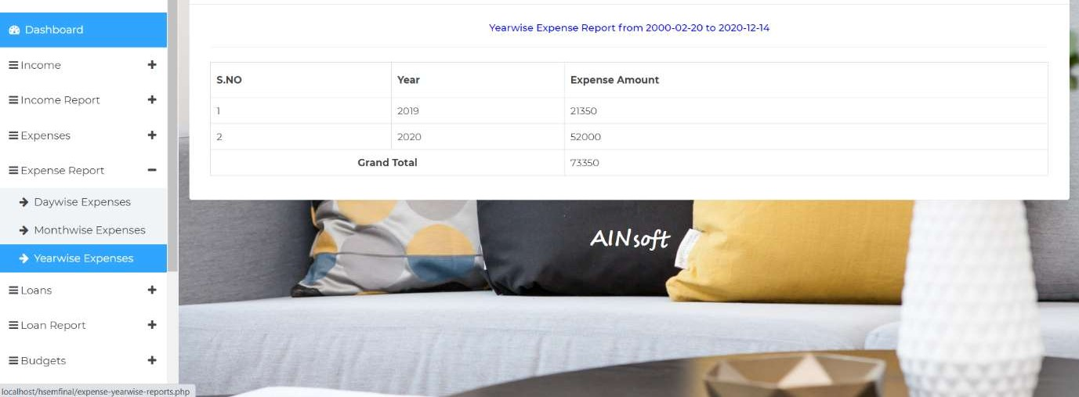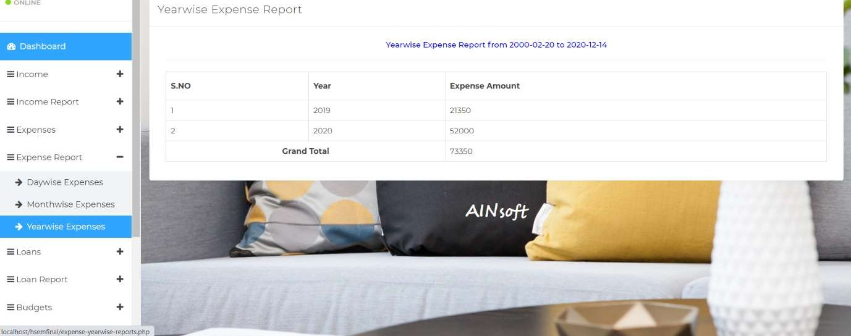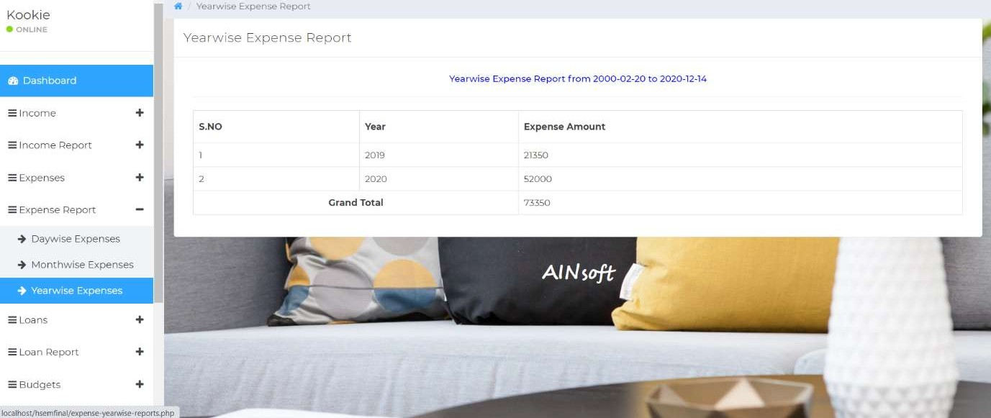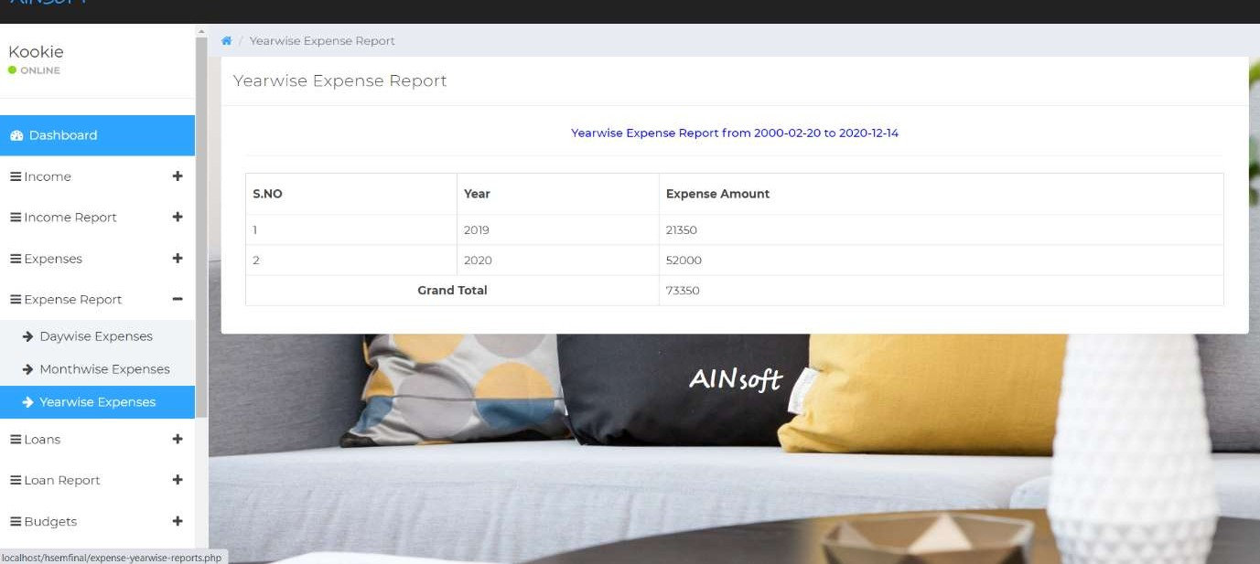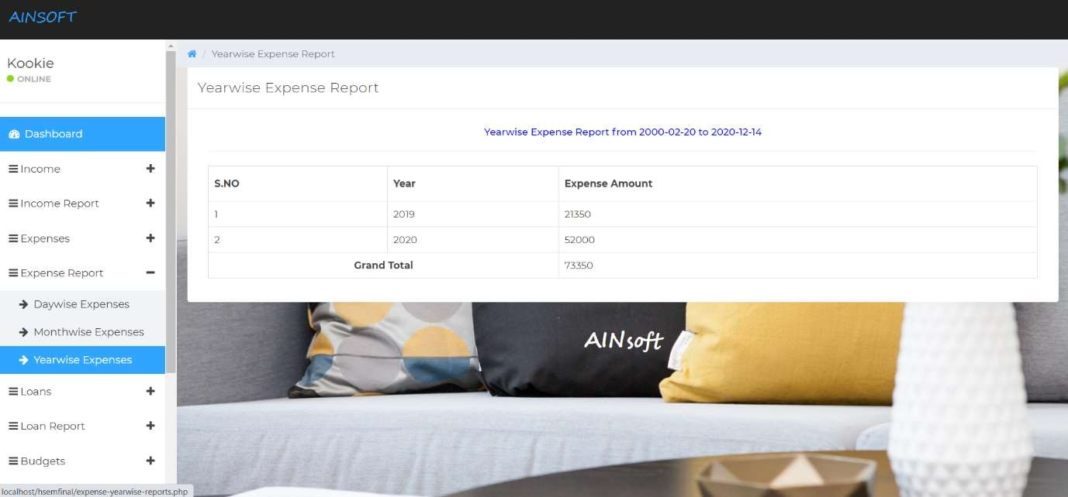

**Fig 6.7.3 View Expense Report – Yearwise**

#### USER - View Loan Report

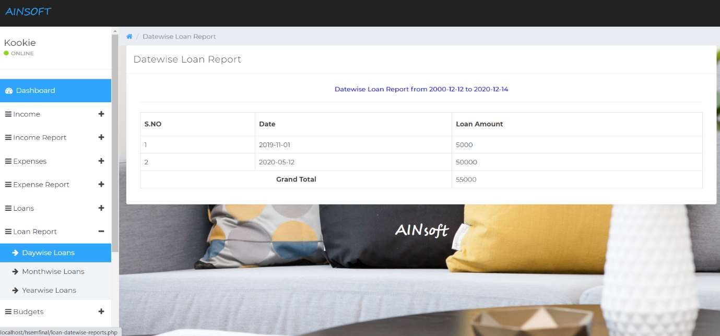

**Fig 6.8.1 View Loan Report – Daywise**

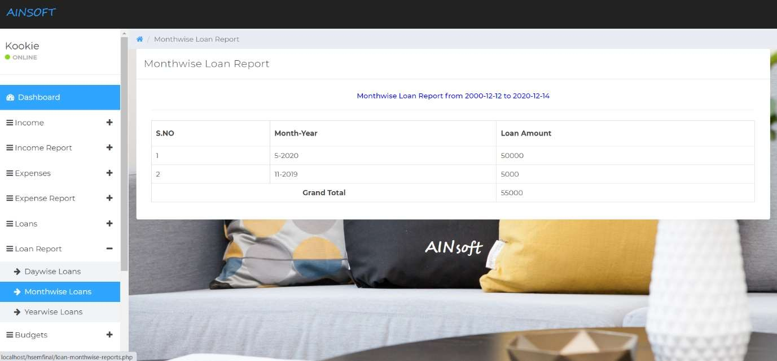

#### Fig 6.8.2 View Loan Report - Monthwise

* 1. **USER - View Budget Report**

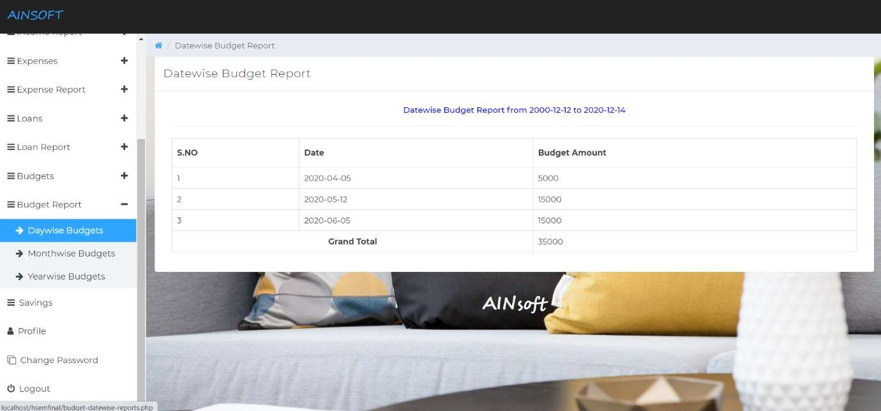

#### Fig 6.9.1 View Budget Report – Daywise

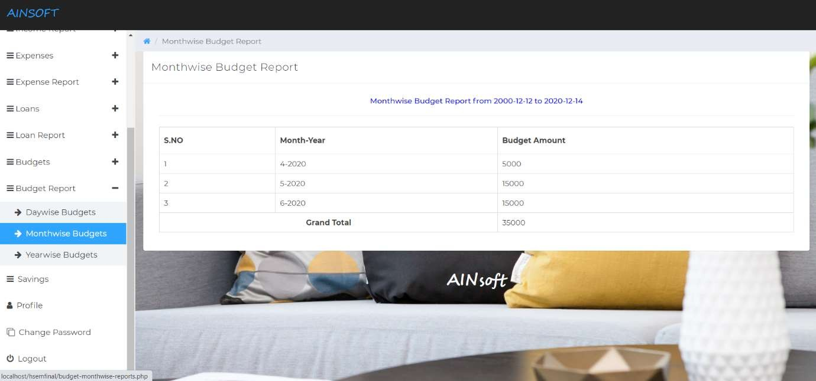

**Fig 6.9.2 View Budget Report - Monthwise**

#### ADMIN – Manage Users and Manage Users’ Log

The admins can manage all the registered users and can also track the activities of all the users.

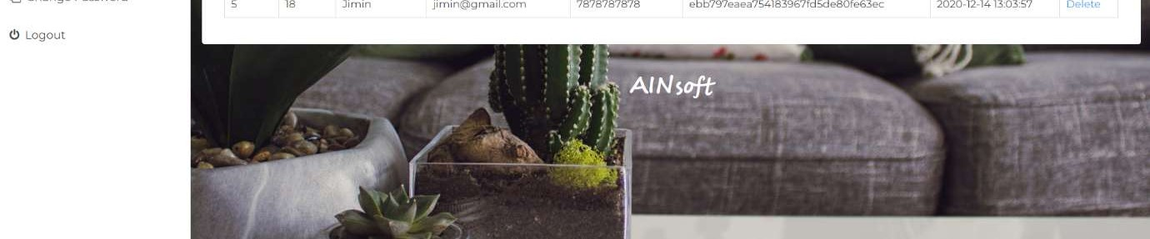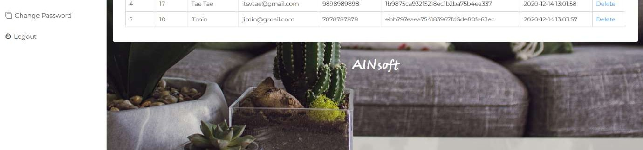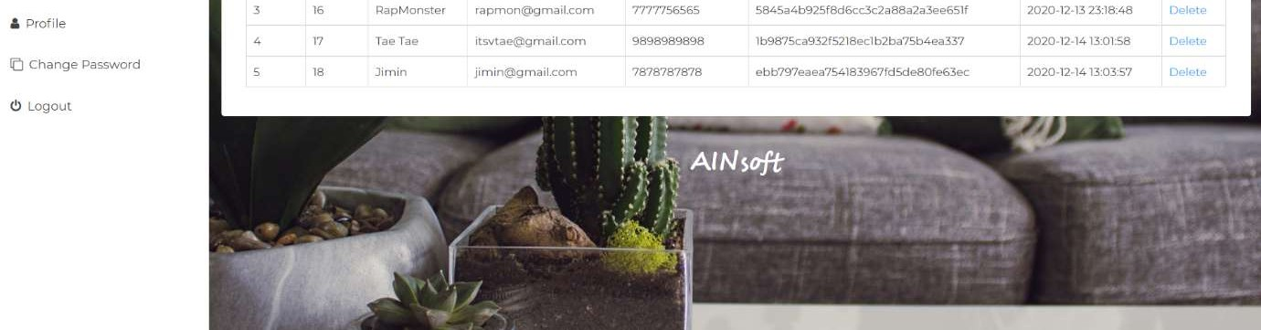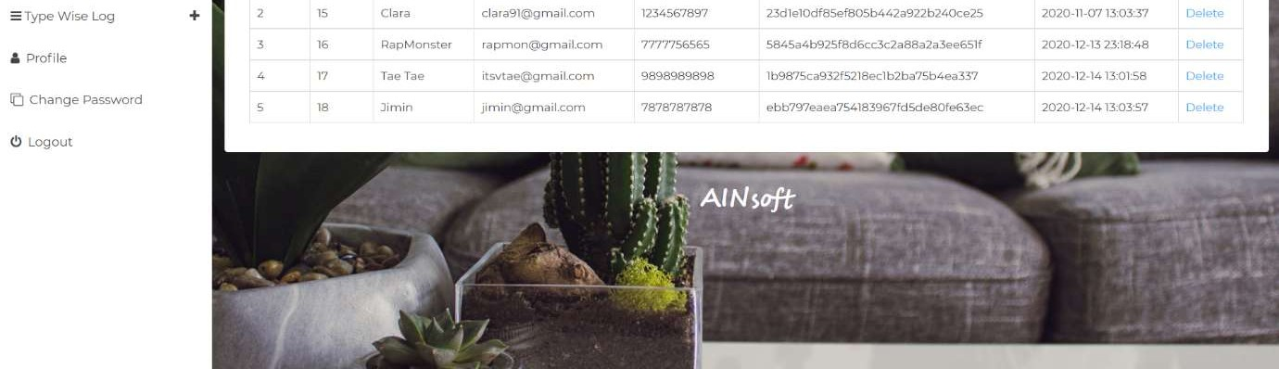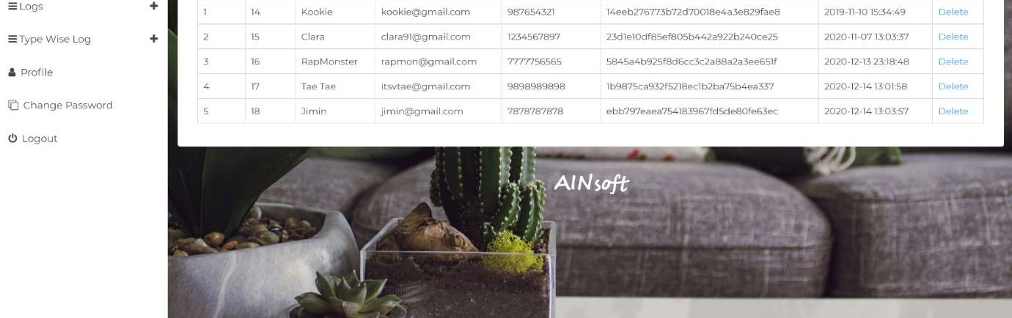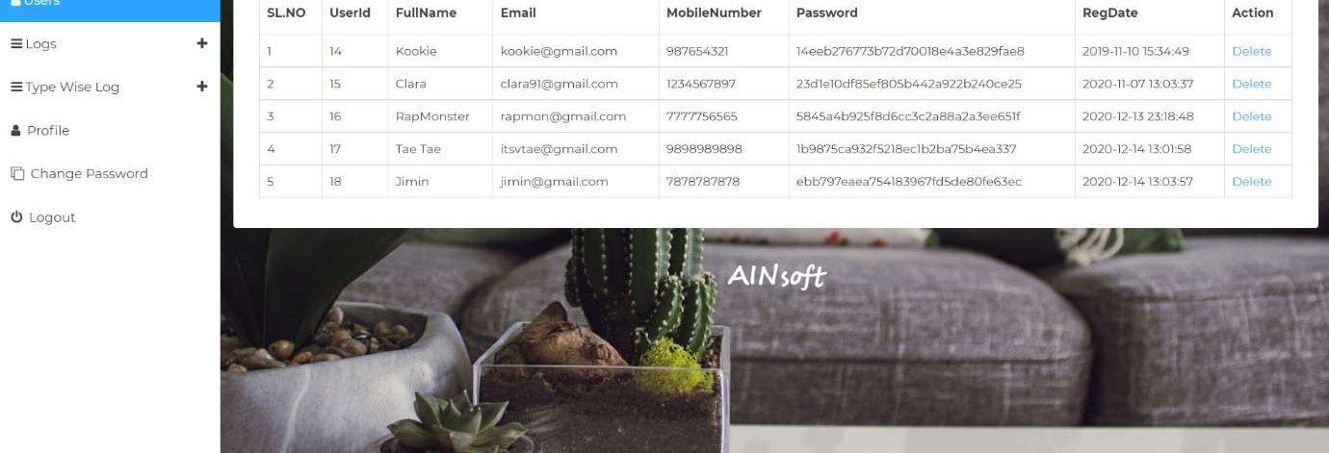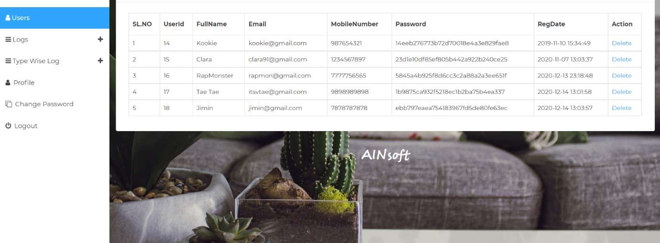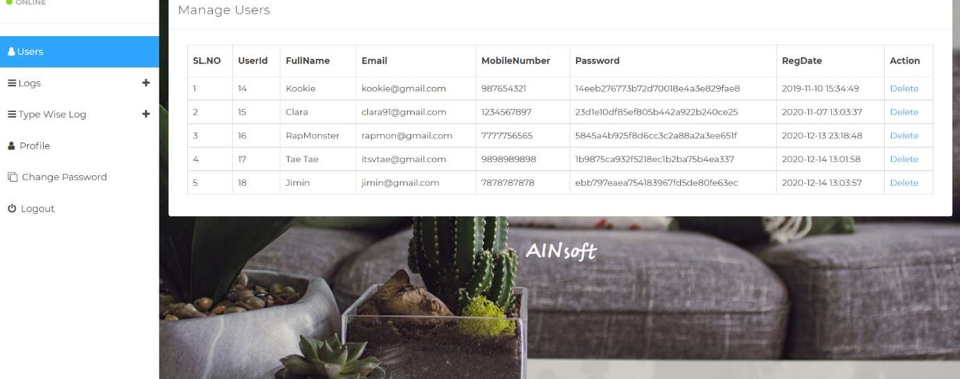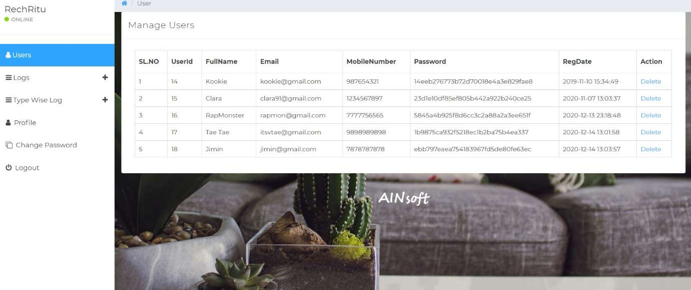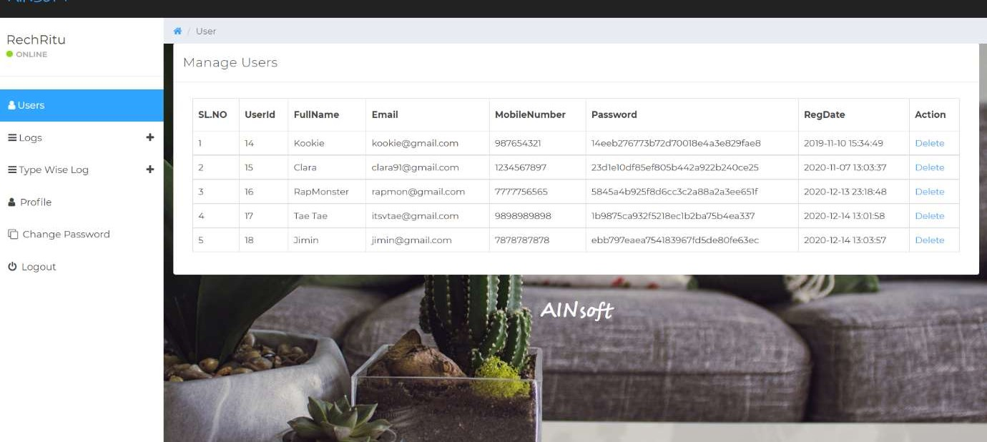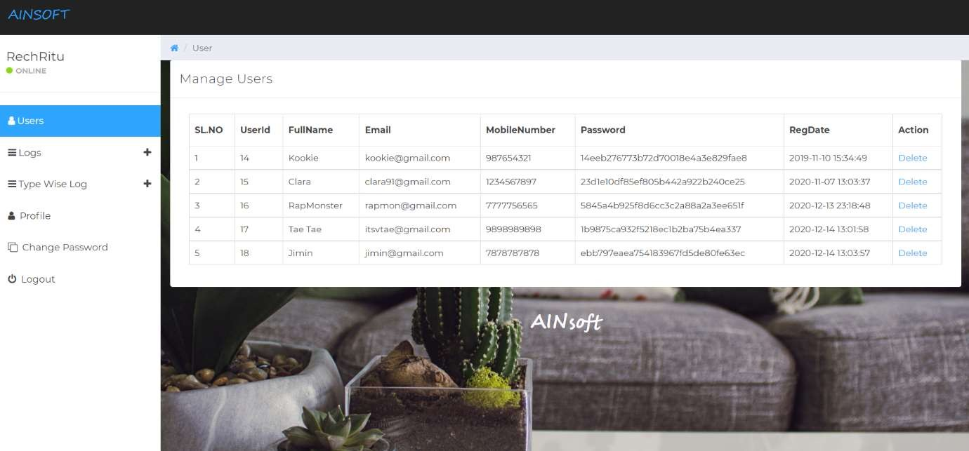

#### Fig 6.10.1 ADMIN – Manage Users

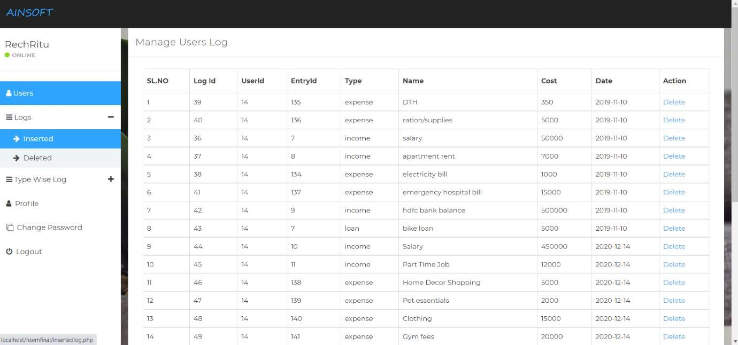

**Fig 6.10.2 ADMIN – Manage Users’ Log**

#### Admin Profile page and Change Admin Password page

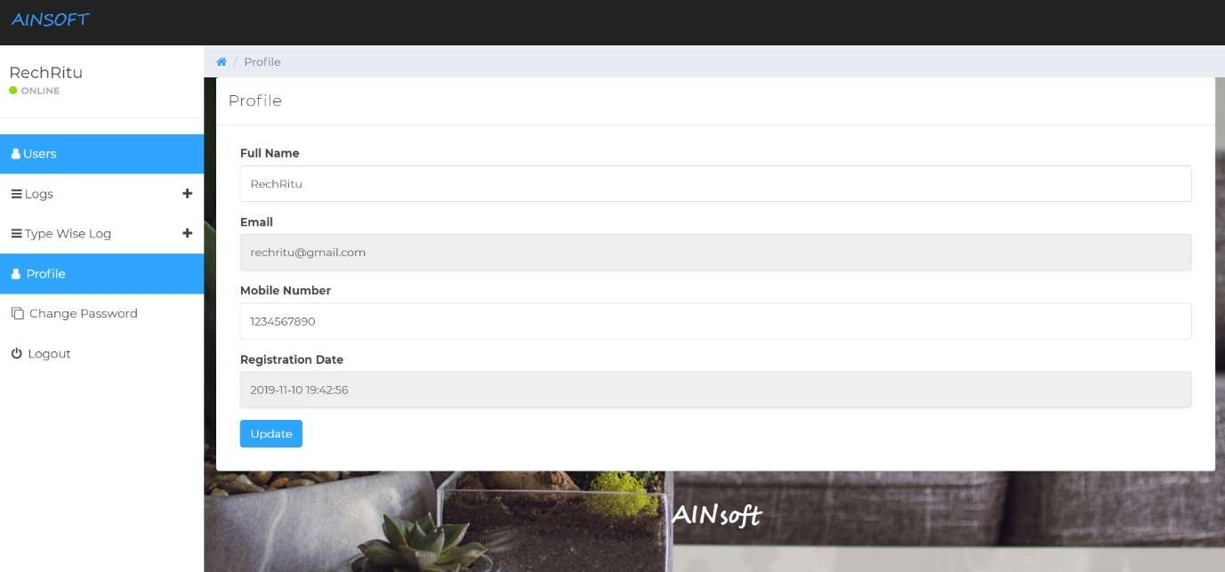

**Fig 6.11.1 Admin Profile page**

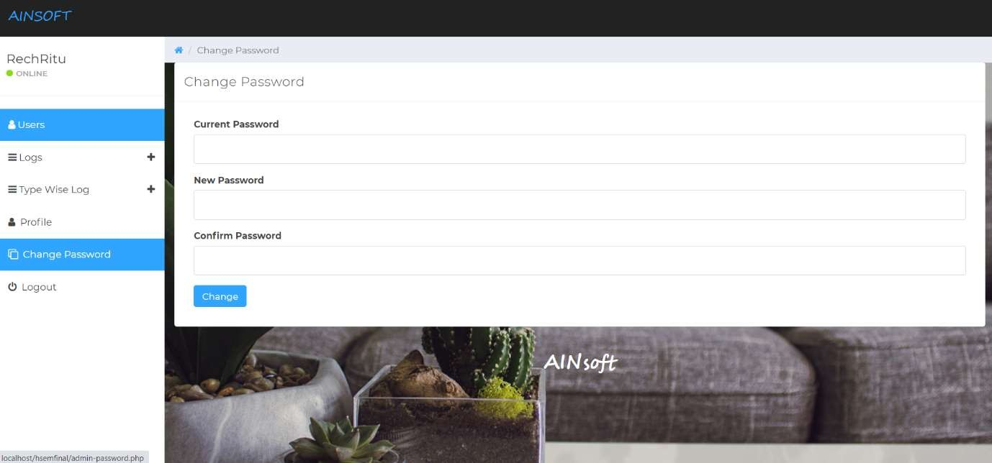

#### Fig 6.11.2 Change Admin Password page

* 1. **ADMIN – Type wise Log View**

The admin can view the users’ log of a particular category.

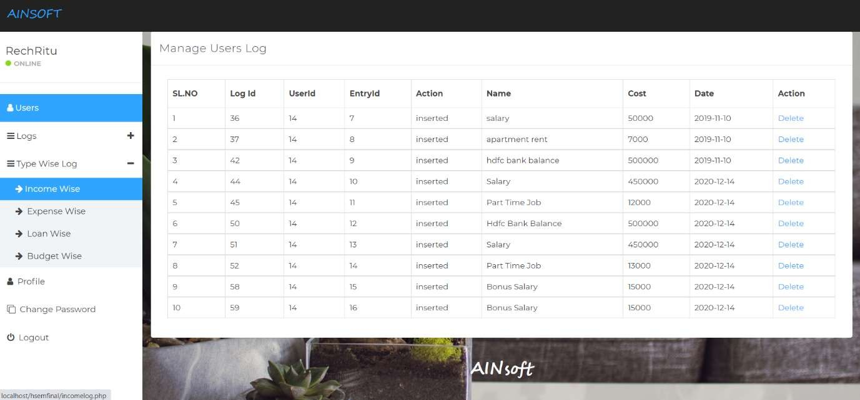

#### Fig 6.12.1 Income wise log view

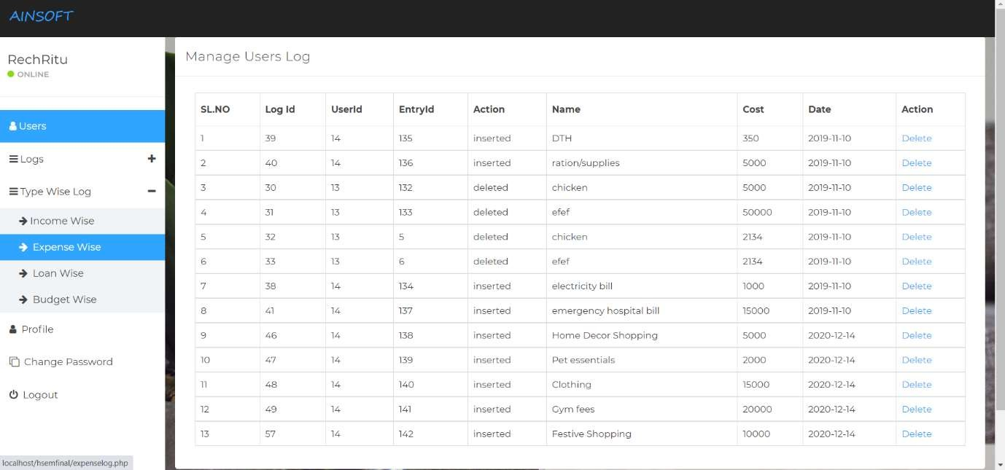

**Fig 6.12.2 Expense wise log view**

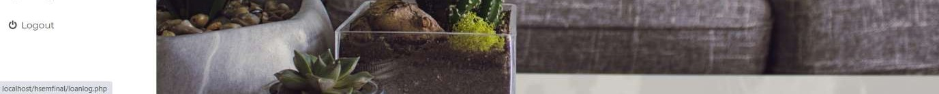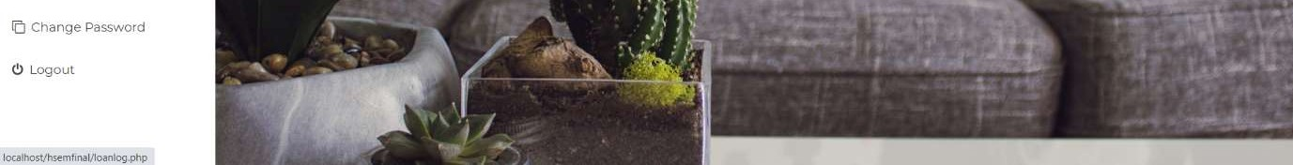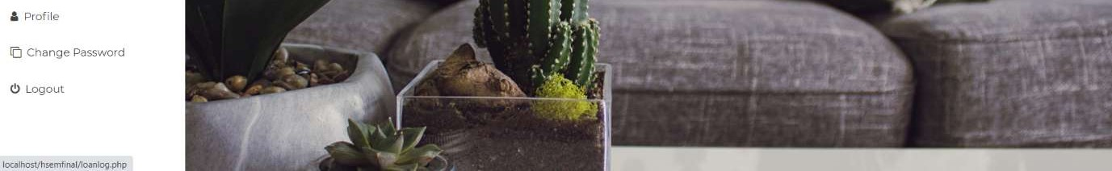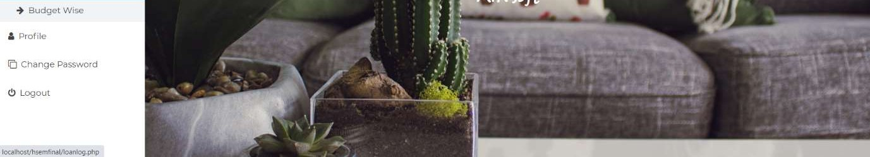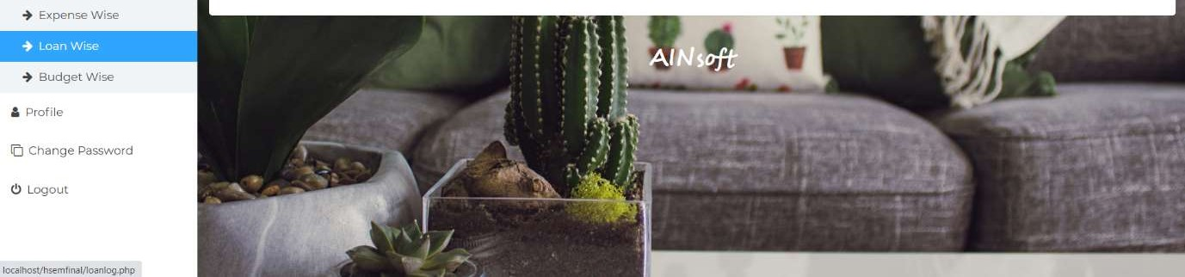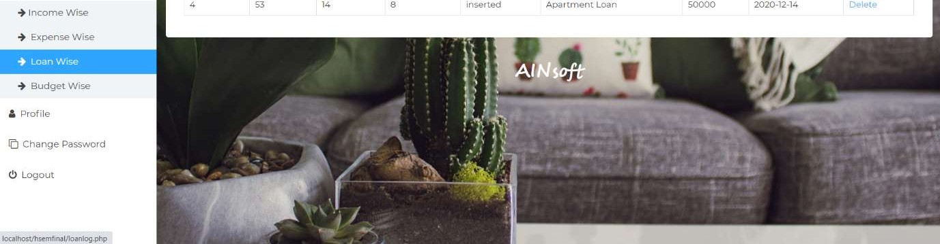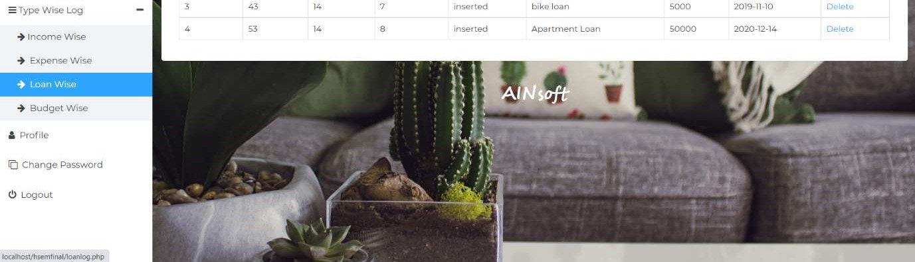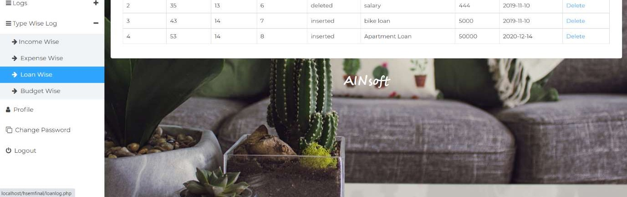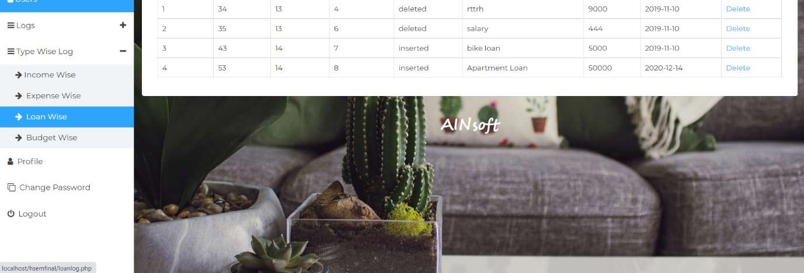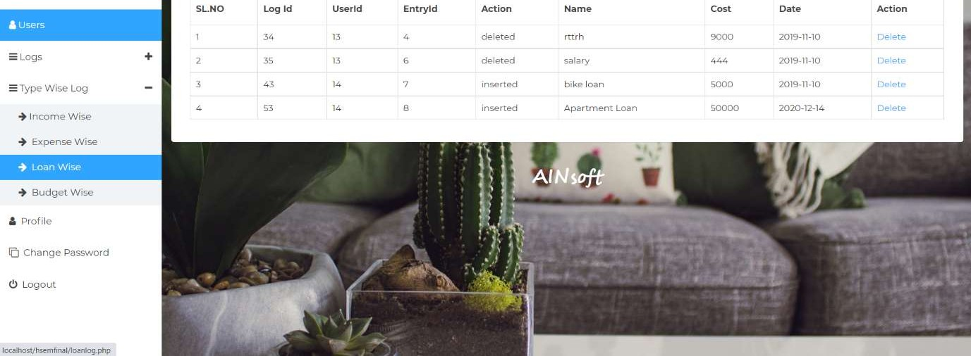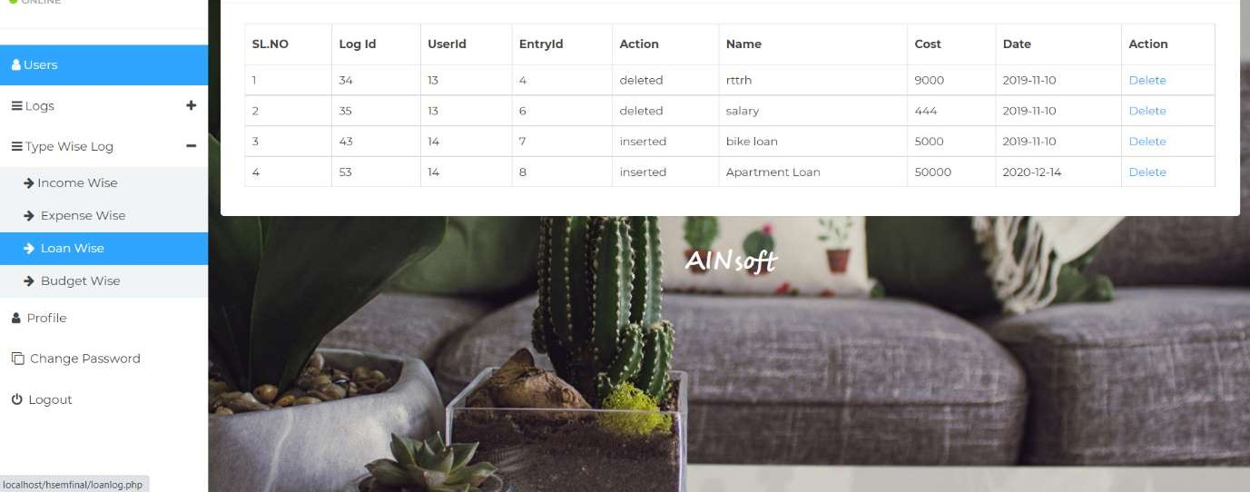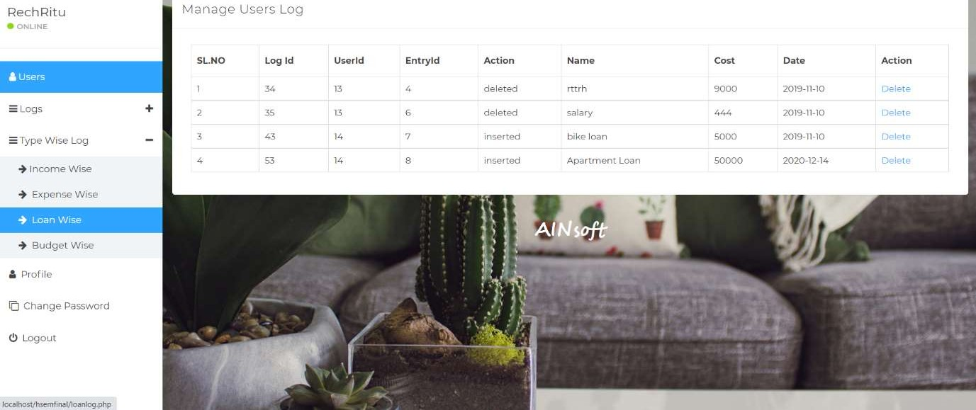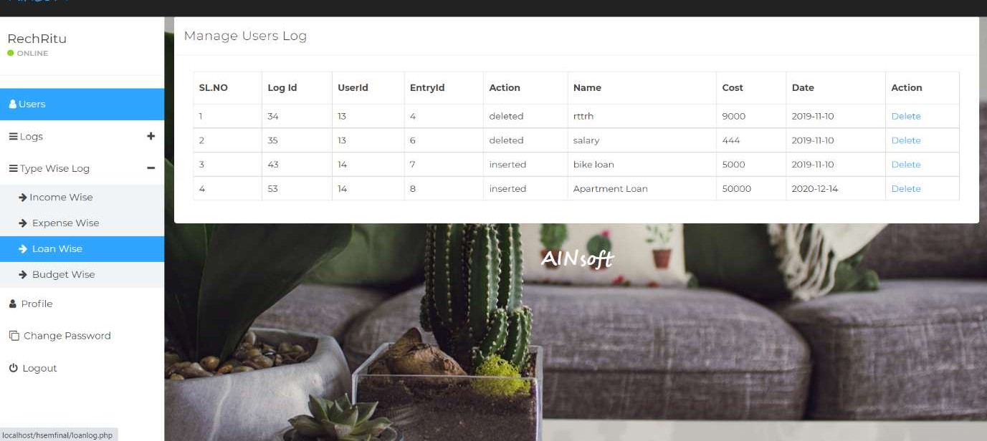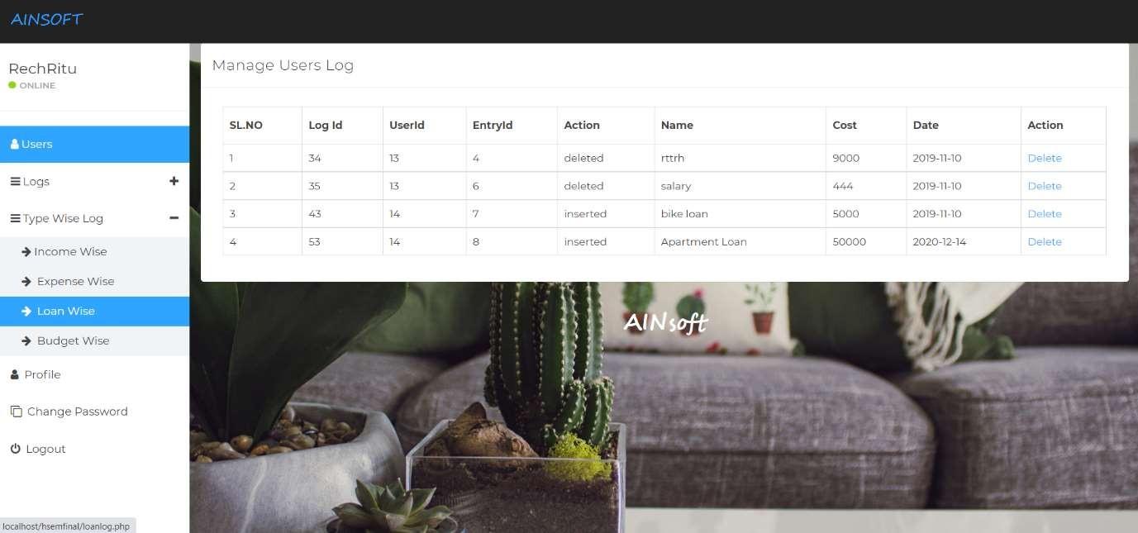

#### Fig 6.12.3 Loan wise log view

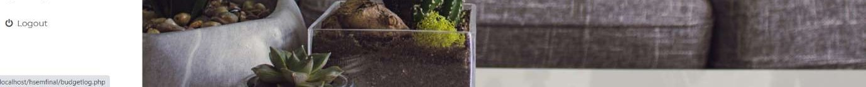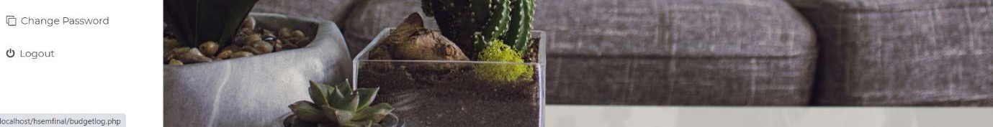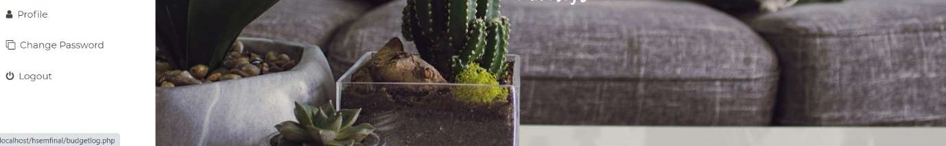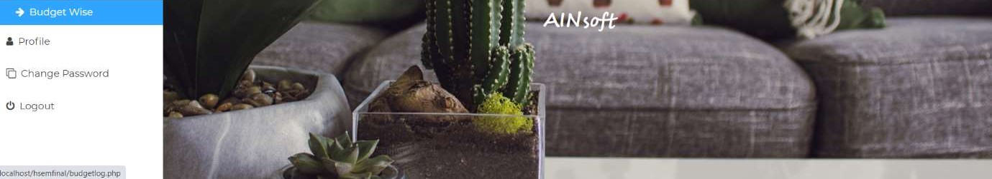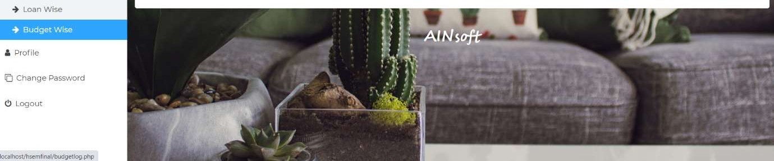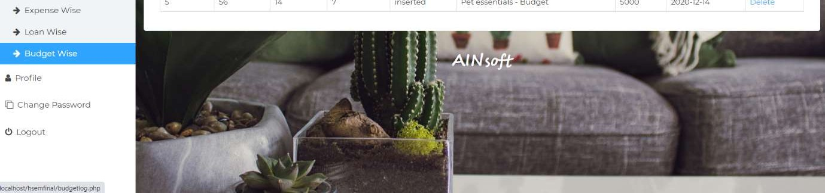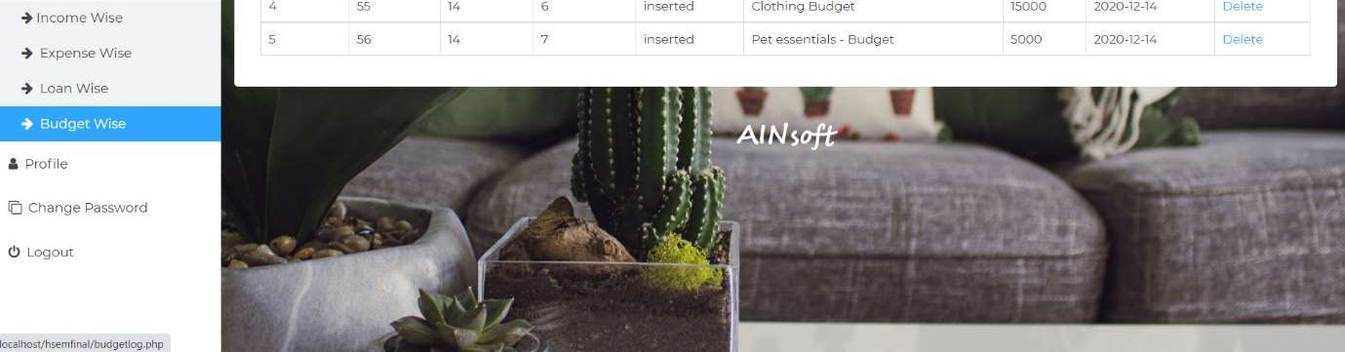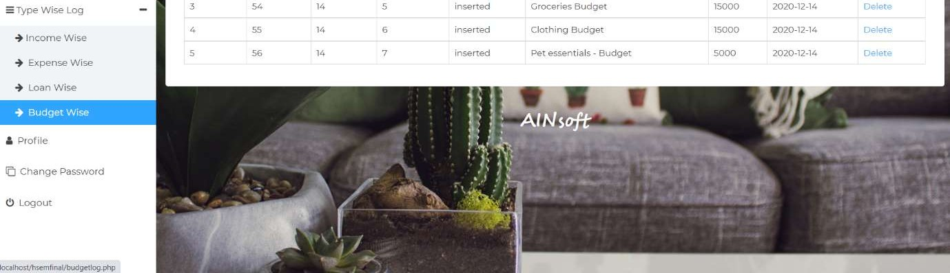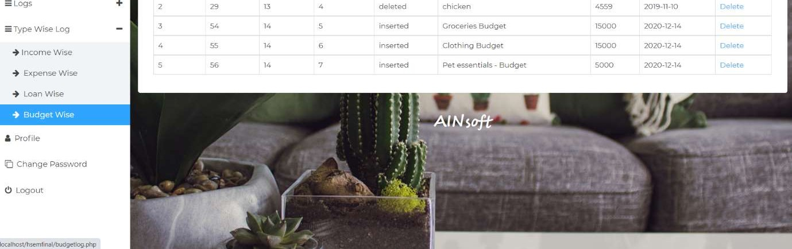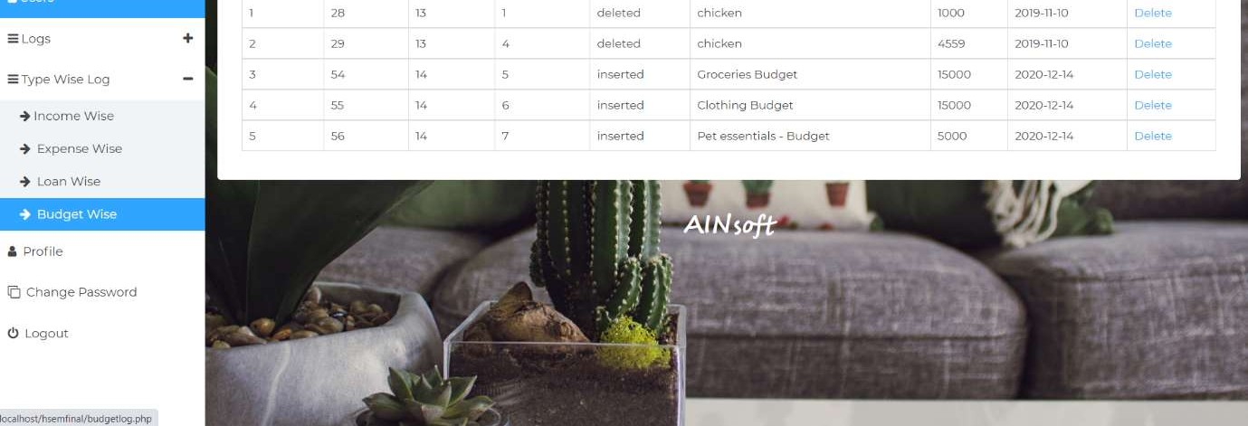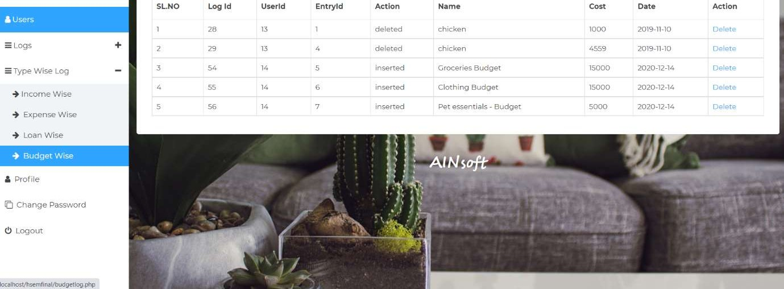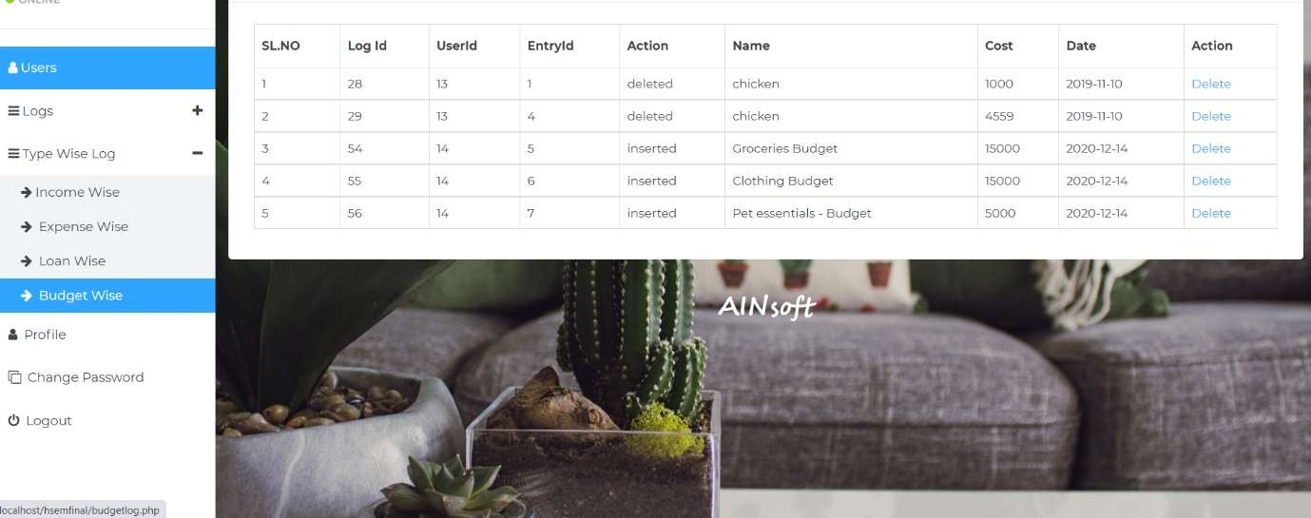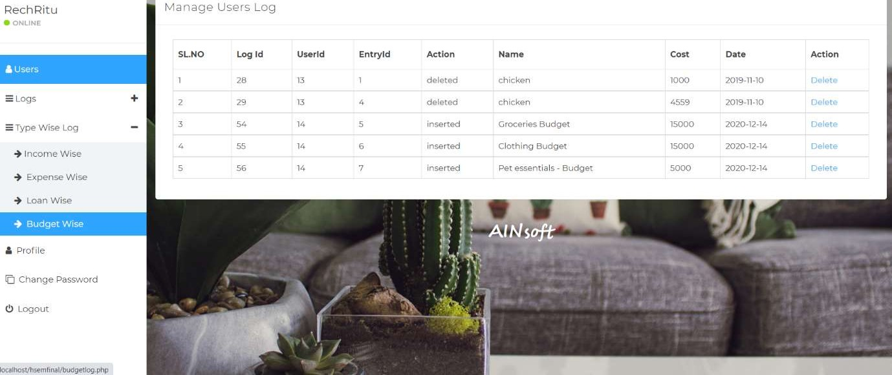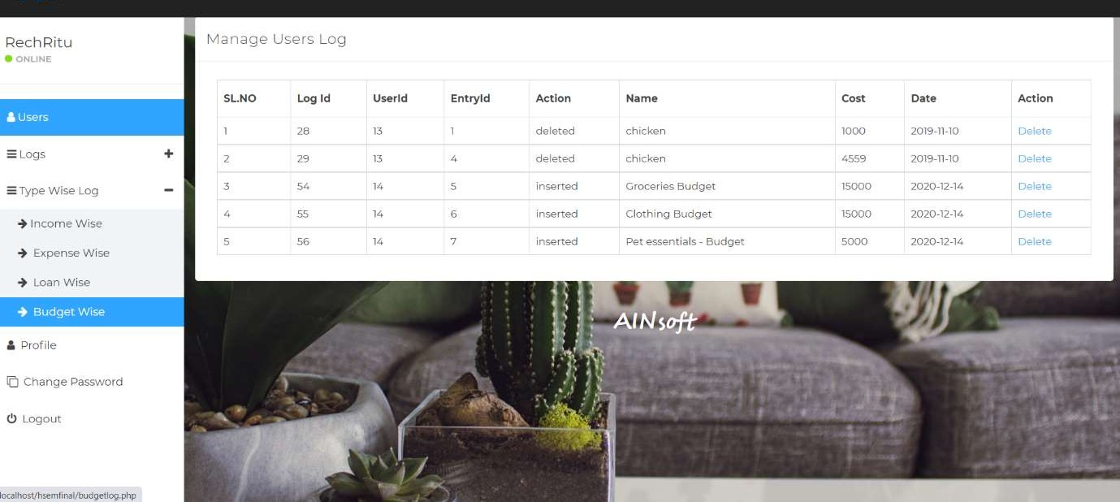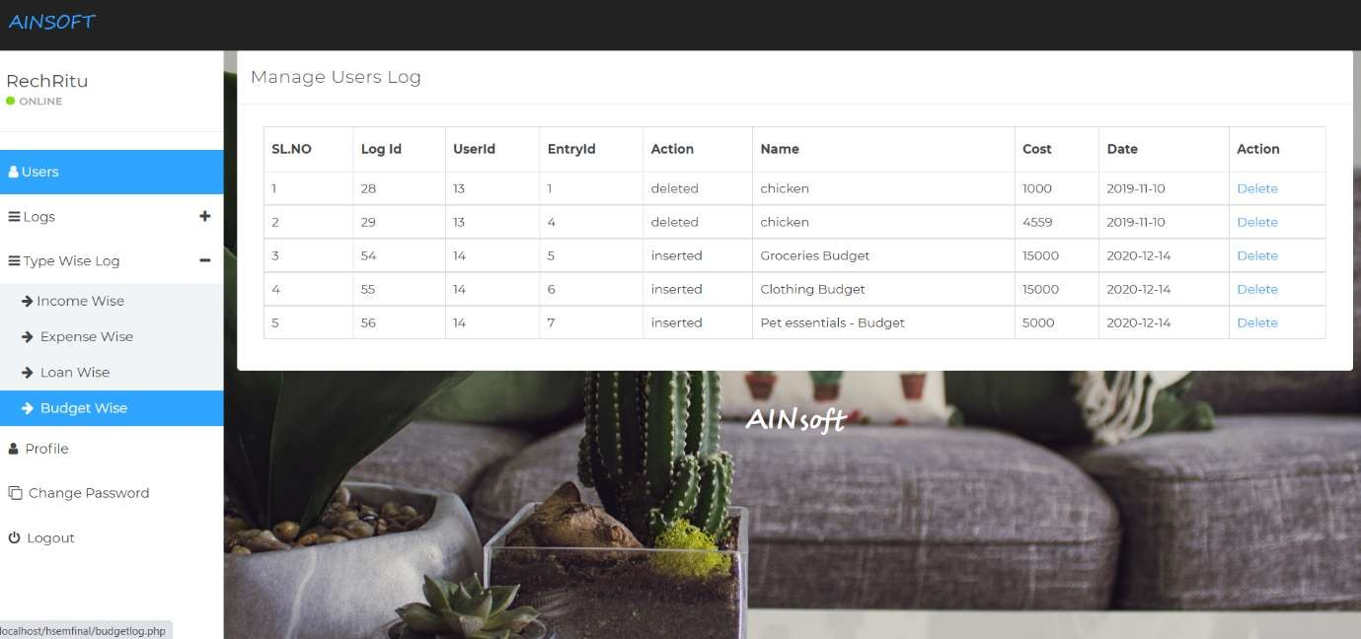

**Fig 6.12.4 Budget wise log view**

#### 6-0 Tables

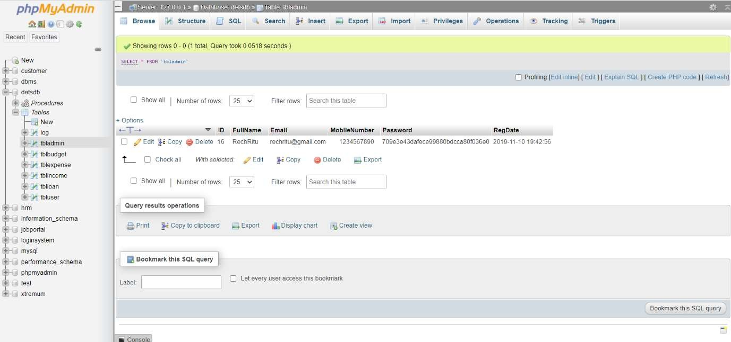**Table 6-1 Admin Table**

#### Table 6-2 User Table

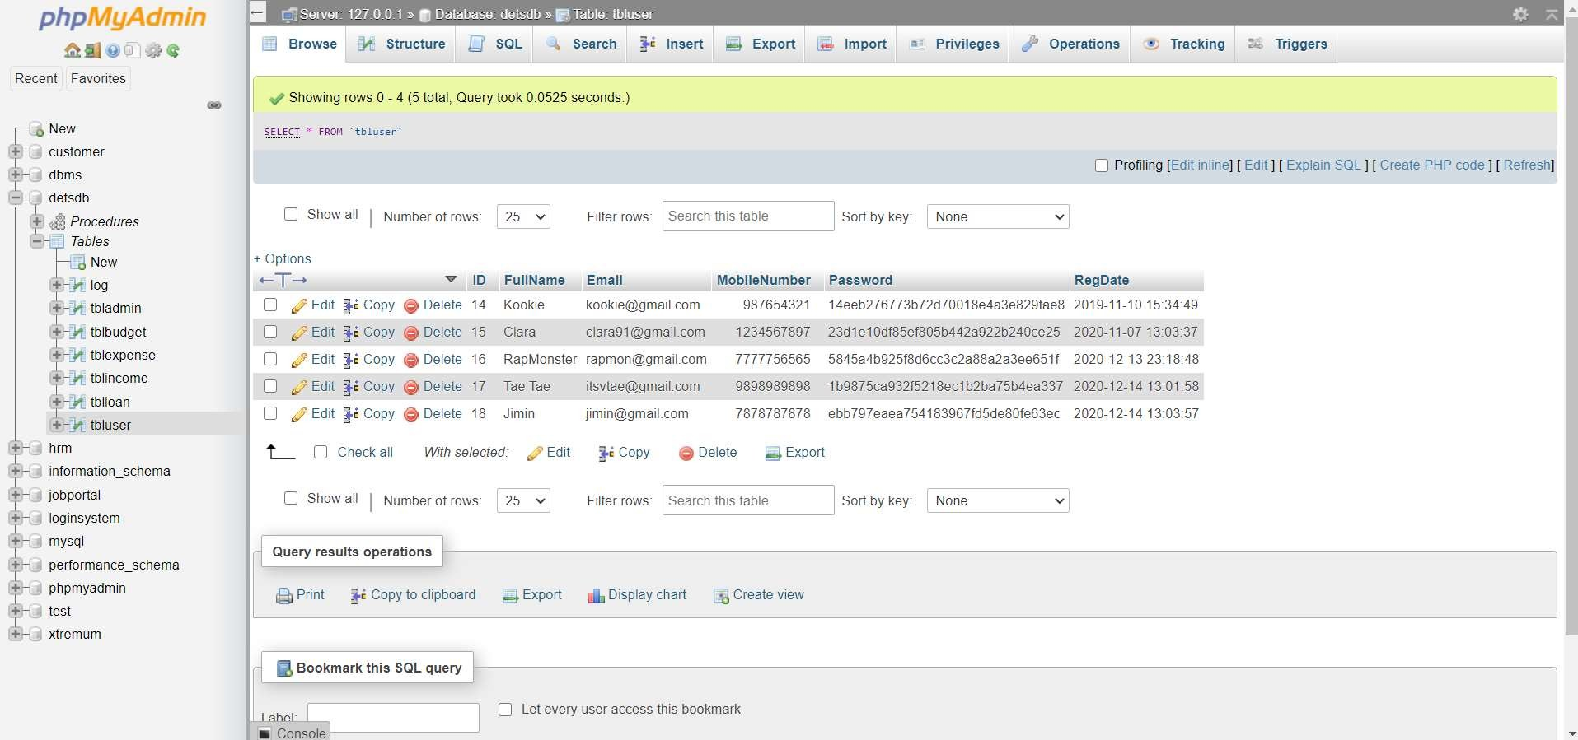

**Table 6-3 Log Table**

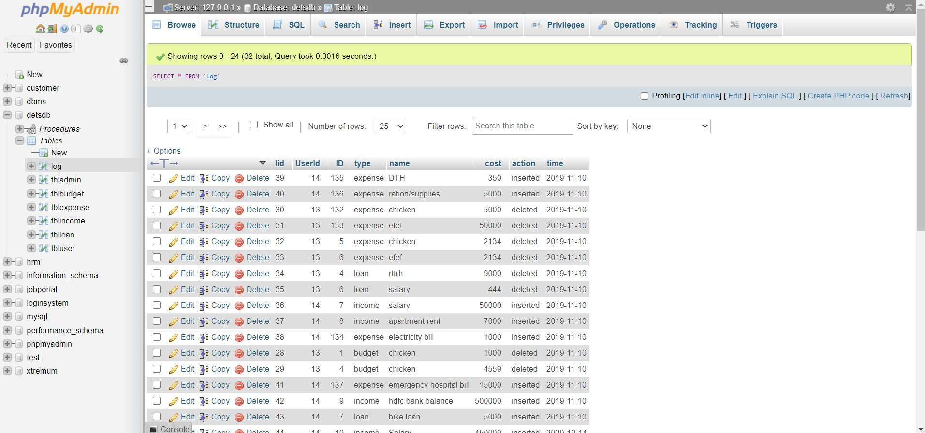

#### Table 6-4 Loan Table

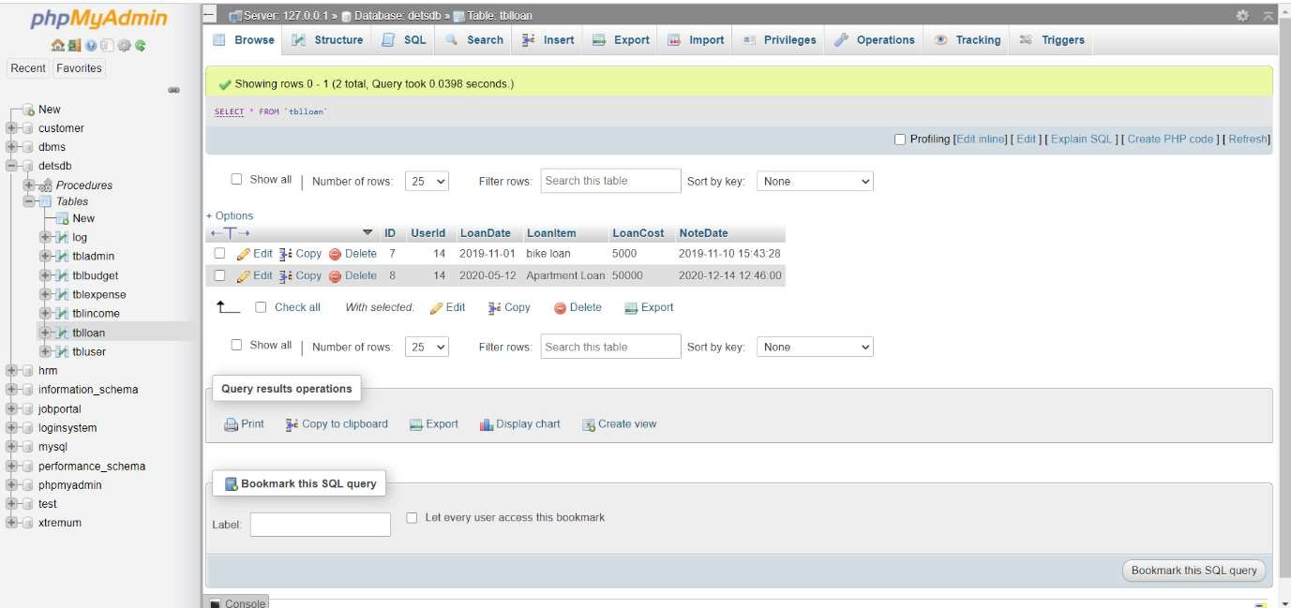

**Table 6-5 Income Table**

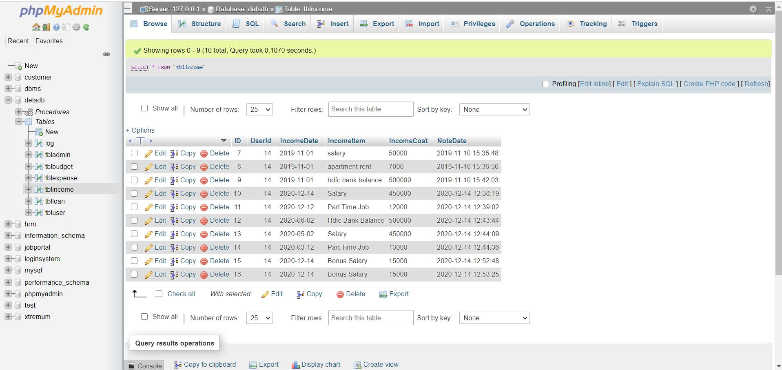

#### Table 6-6 Budget Table

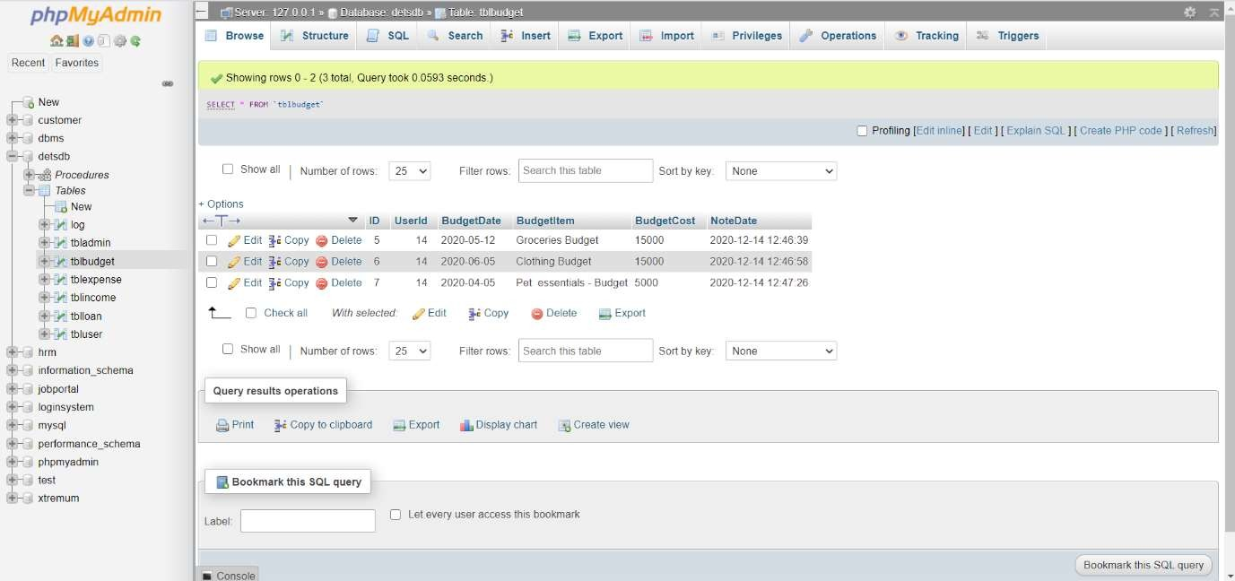

**Table 6-7 Expense Table**

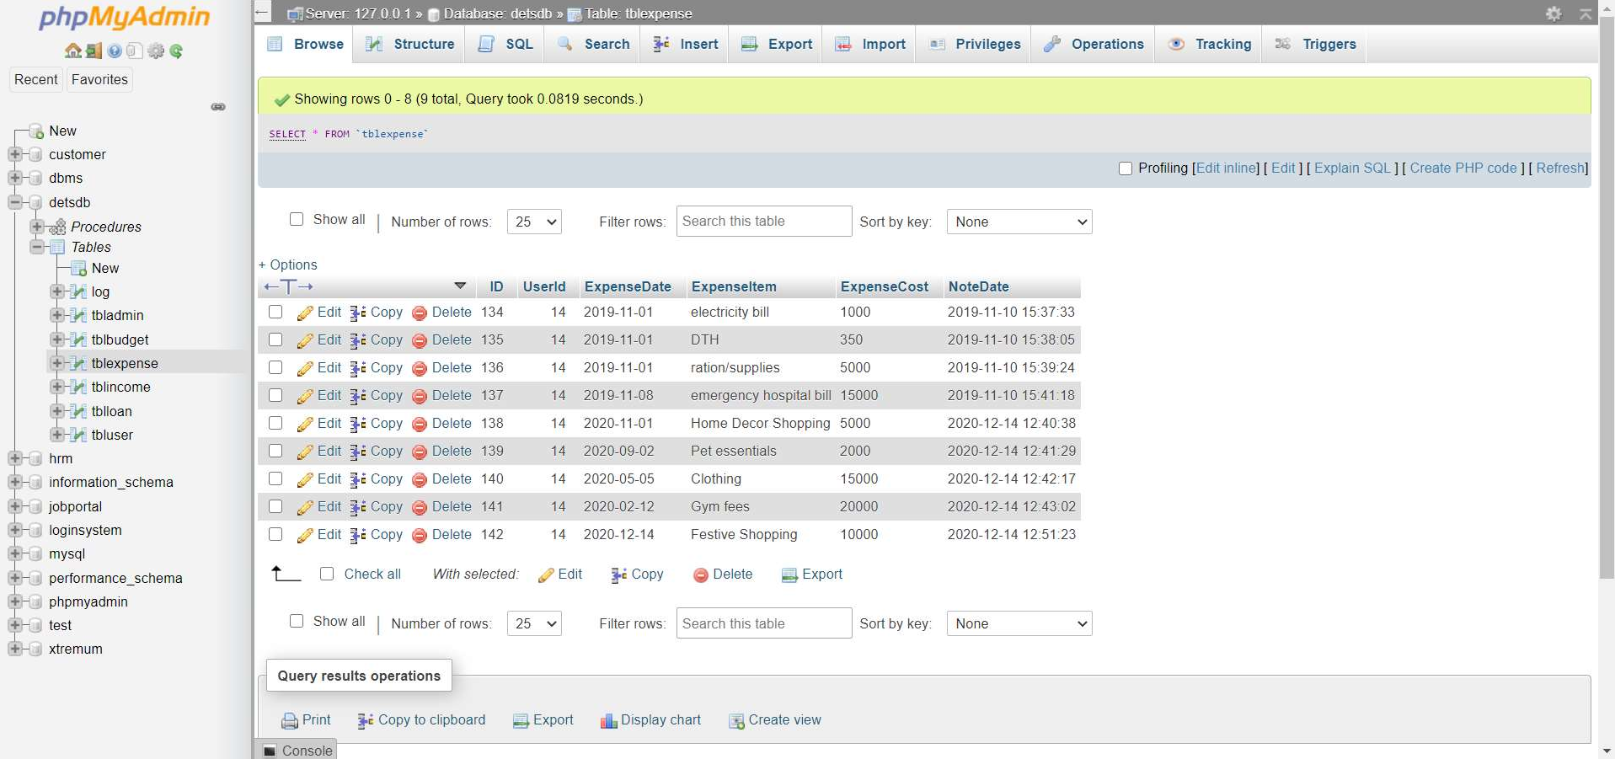

## Chapter 7

# Conclusion

What we have here is easy to use, highly beneficial website. The design of the website is done by taking in to the consideration of all the user’s needs, boxing them and presenting it in the best way possible. Using the website saves the much needed time and helps streamline the entire process.

The website has been completed successfully and tested with suitable test cases. It is user friendly and contains suitable options for all users. This project is part of the spearhead the pierces the veil of redundancy and creates a future where everything is on the web and easily accessible.

Household Savings and Expenditure Mangement System, is a project aimed to reduce paperwork and to bring relative ease to manage large data in terms of expenses and income.

* This is also used to keep track of old as well as new and update expenses.
* It allows one to keep a list of all types of expenses and income information based on the user, expenditure, unique id, description of the expenditure and this software can also be used to
* See the feedbacks of the users and act according about the users.
* It also has an about page which discuss about the users.

# References

[1]. The Bootstrap Website (for Design) – https://getbootstrap.com/

[2]. W3 Schools (HTML, CSS, JS and PHP reference) – https://[www.w3schools.com/](http://www.w3schools.com/)

[3]. PHP Official Documentation – https://php.net/docs.php/

[4]. The MySQL Documentation – https://dev.mysql.com/doc/

[5]. Stack Overflow – https://stackoverflow.com/

[6]. Stack Exchange – https://stackexchange.com/

[7]. Wikipedia – https://[www.wikipedia.org/](http://www.wikipedia.org/)